Western Mathematics Exams

School Name

Yearly Examination
2016
Year 10
Mathematics Course

Solutions
Year 10 |  | WME Solutions  Mathematics Yearly 2016 | Non Calculator
Section 1 Short Answer Section
ANSWERS
No. | WORKING |  | ANSWER
 | 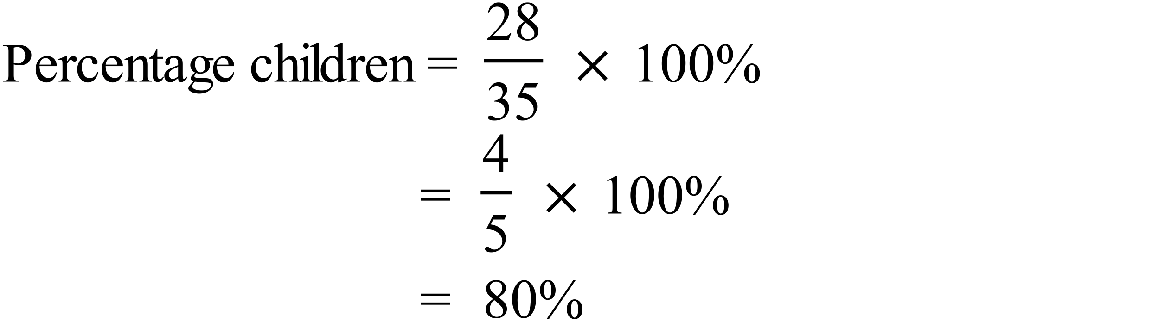 |  | 80%
 | 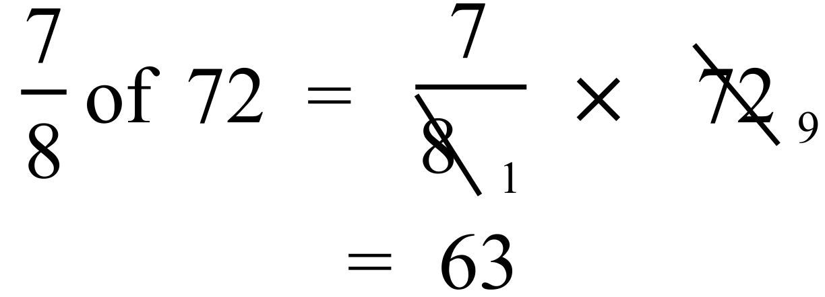 |  | 63
 | 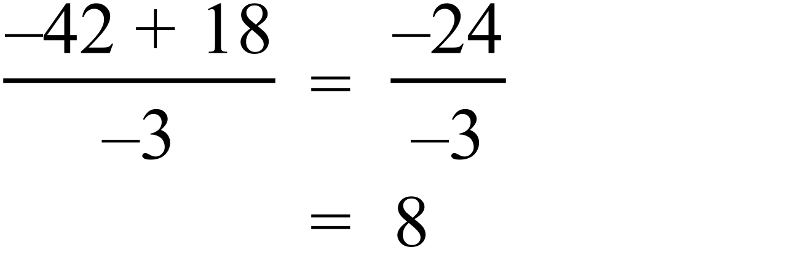 |  | 8
 | 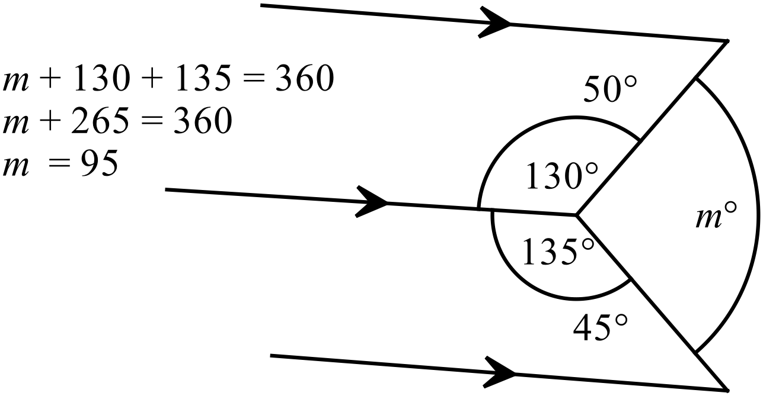 |  | m = 95
 | 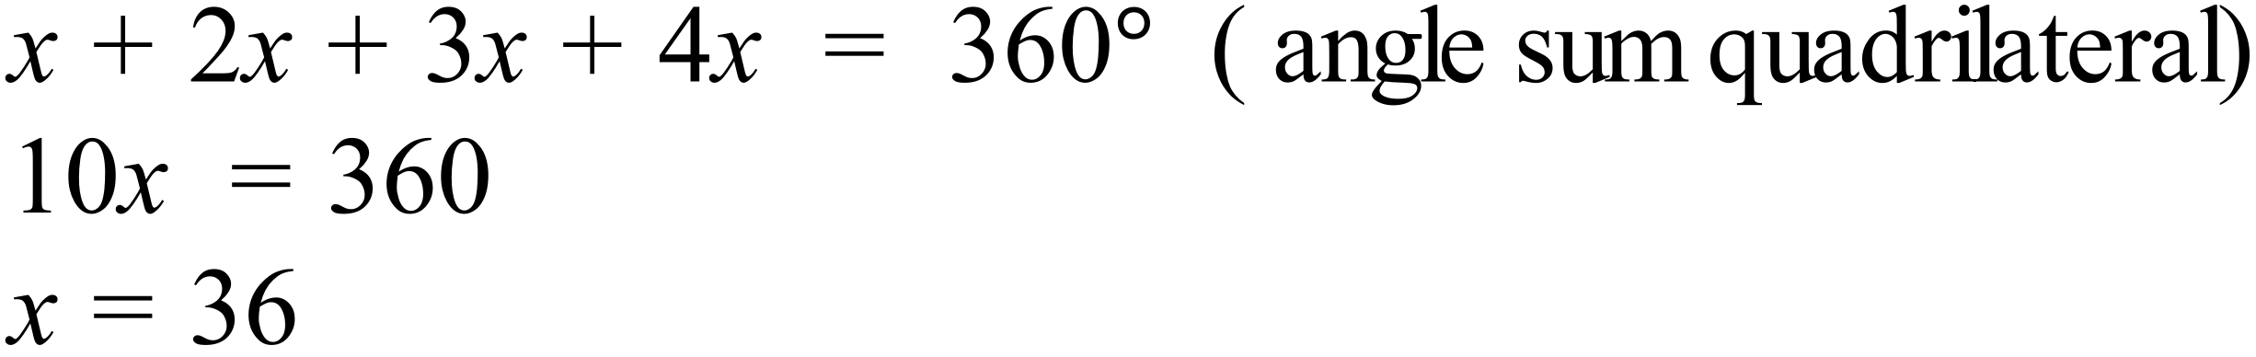 |  | x = 36
 | Glasgow is 9 hours behind, so Sydney is 9 hours ahead of 1:45 pm, which is 10:45 pm on Saturday 12th November. |  | 10:45 pm on Saturday 12th Nov
 | 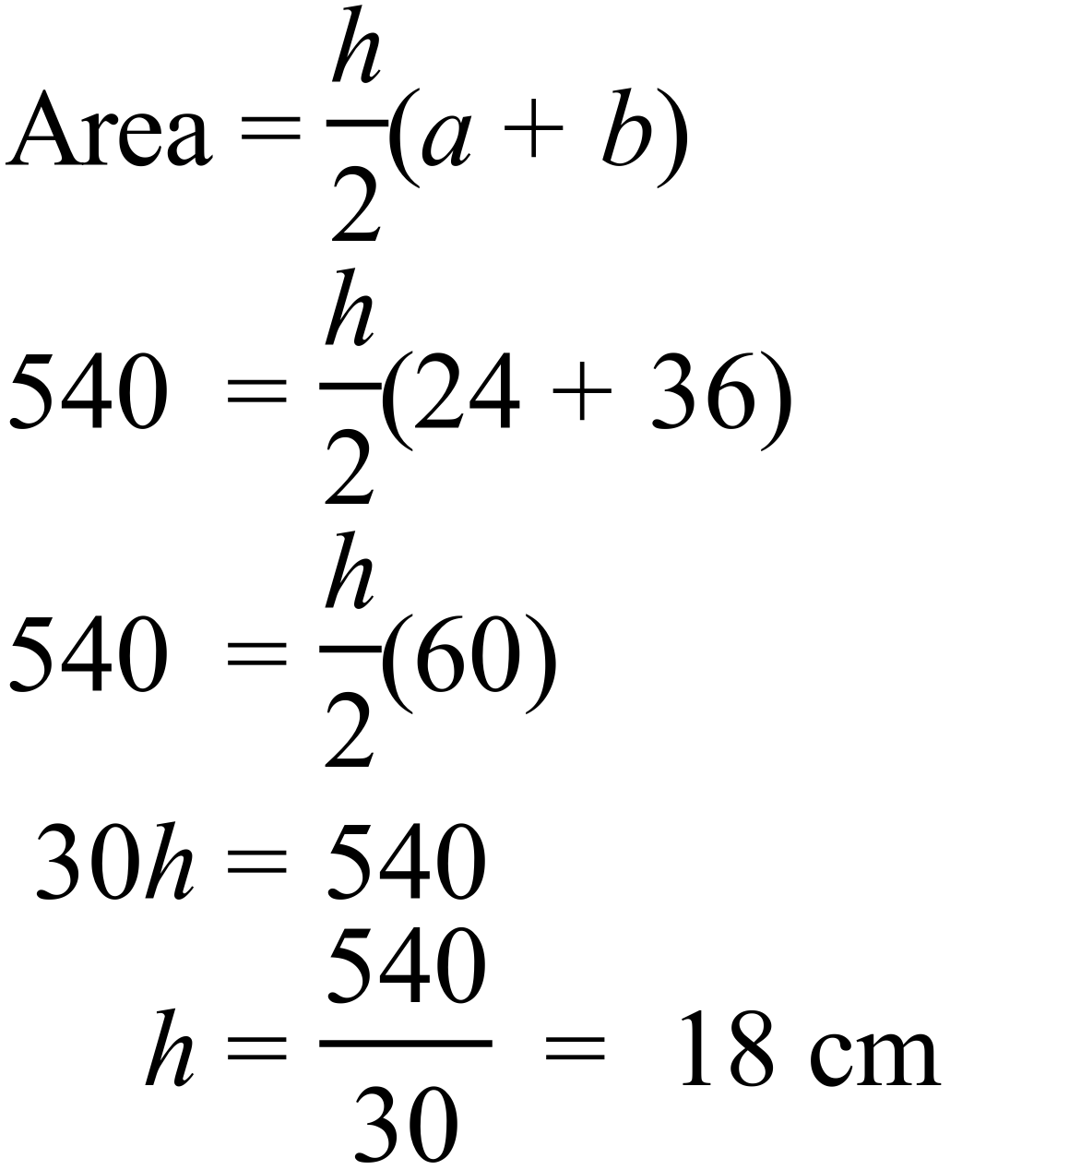 |  | 18 cm
 | 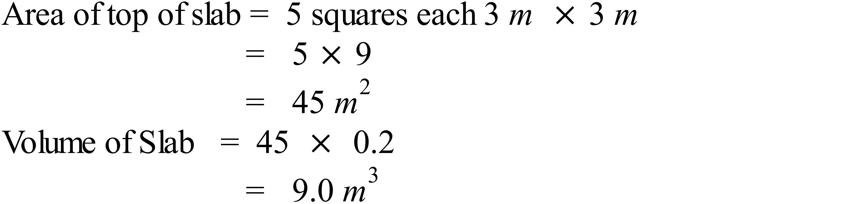 |  | 9 m²
 | 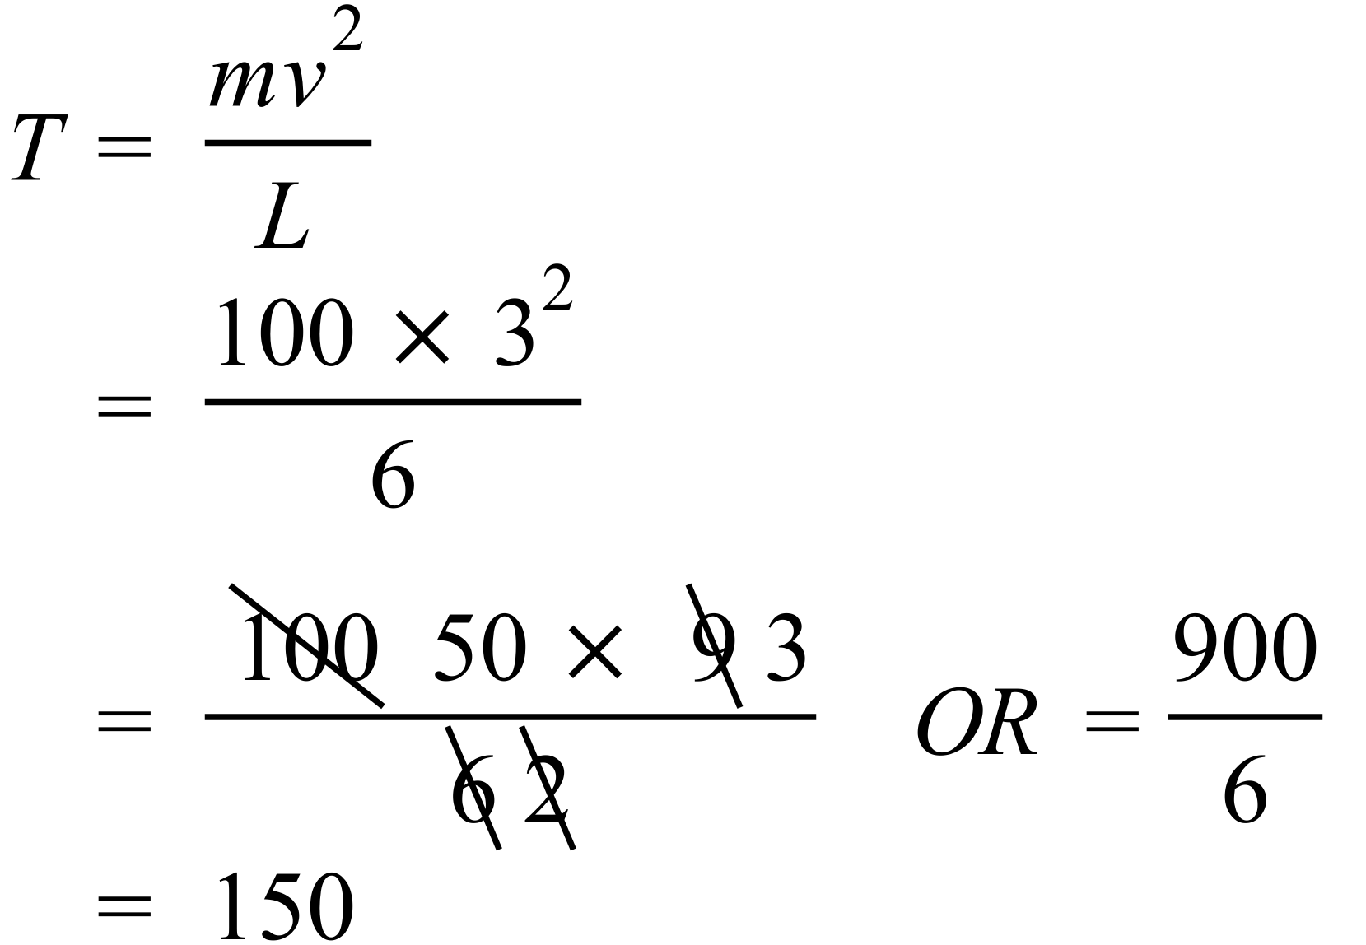 |  | 150
 | 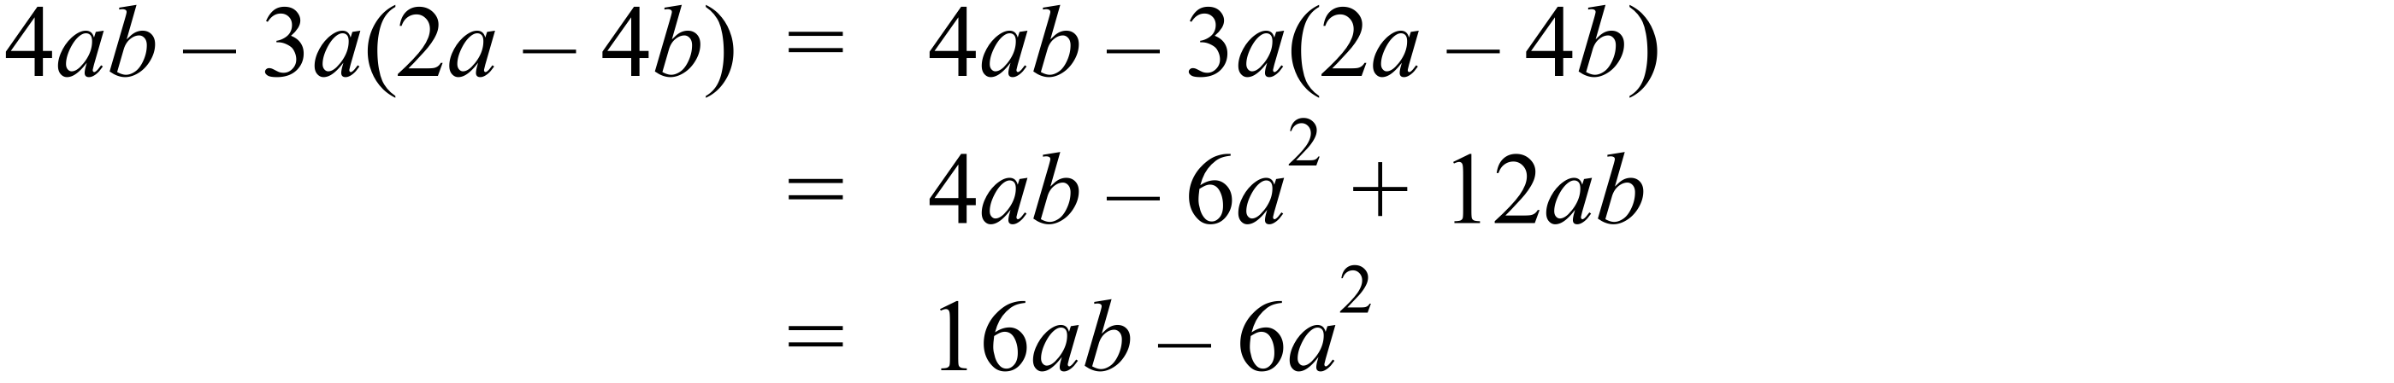 |  | 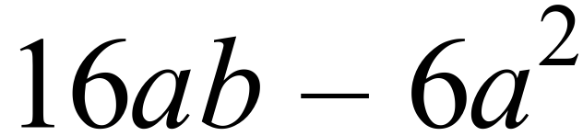
 | 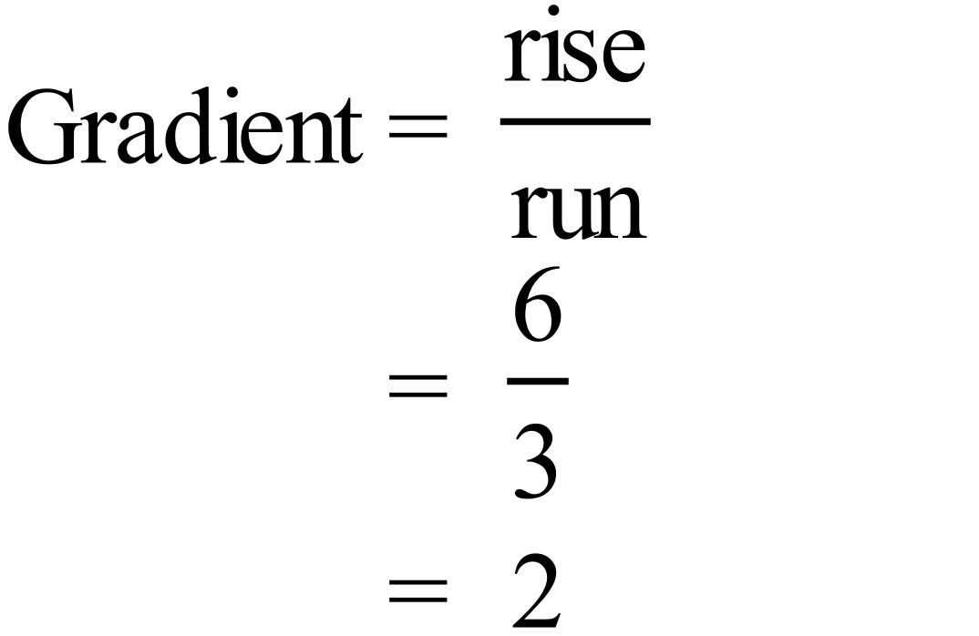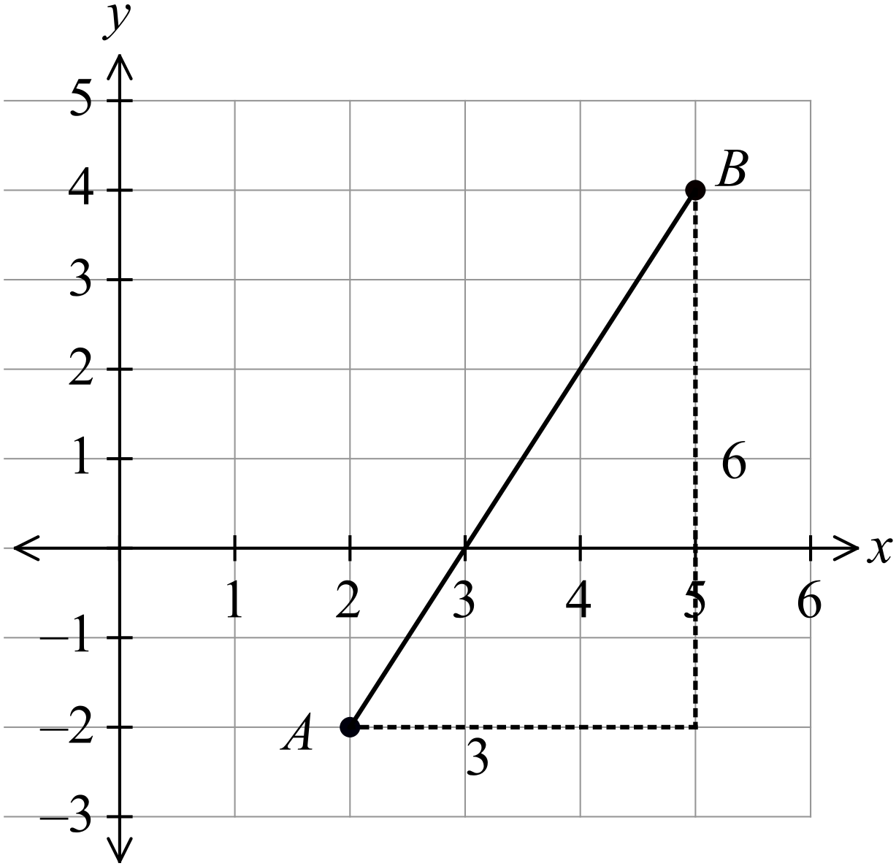 |  | 2
 | 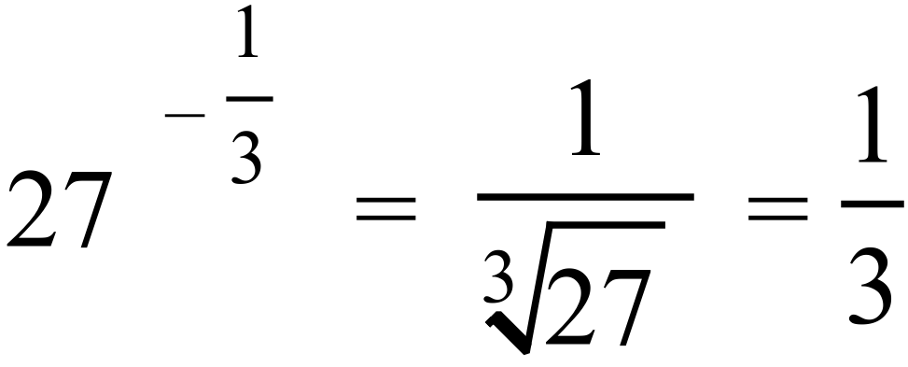 |  | 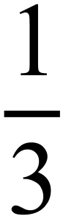
 | 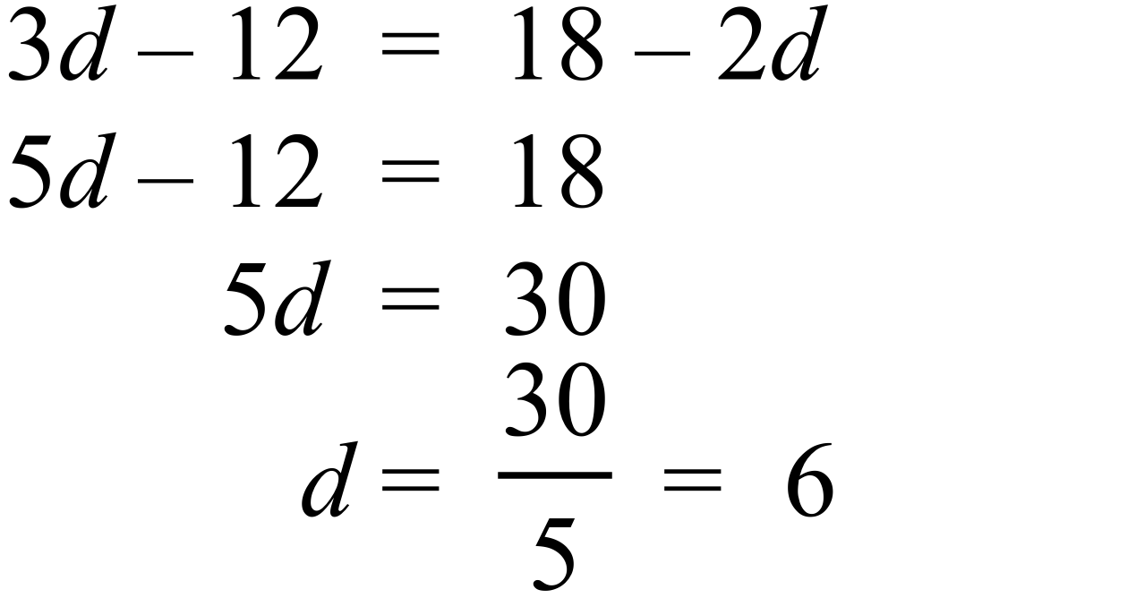. |  | d = 6
 | 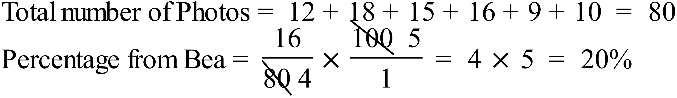 |  | 20%
 | 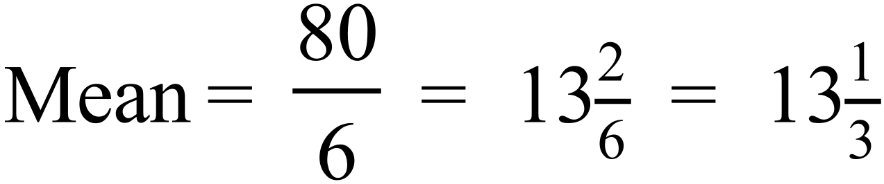 |  | 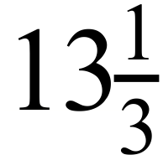
 | 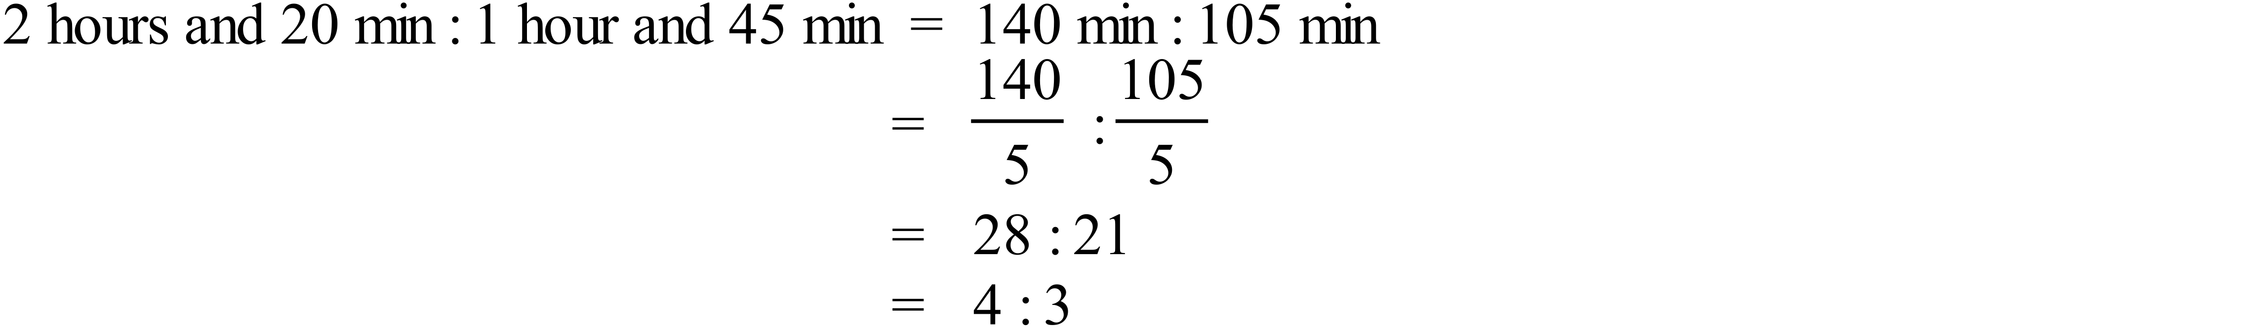 |  | 4 : 3
 | Midpoint of interval joining P (-6, 10) and Q (4, 5)  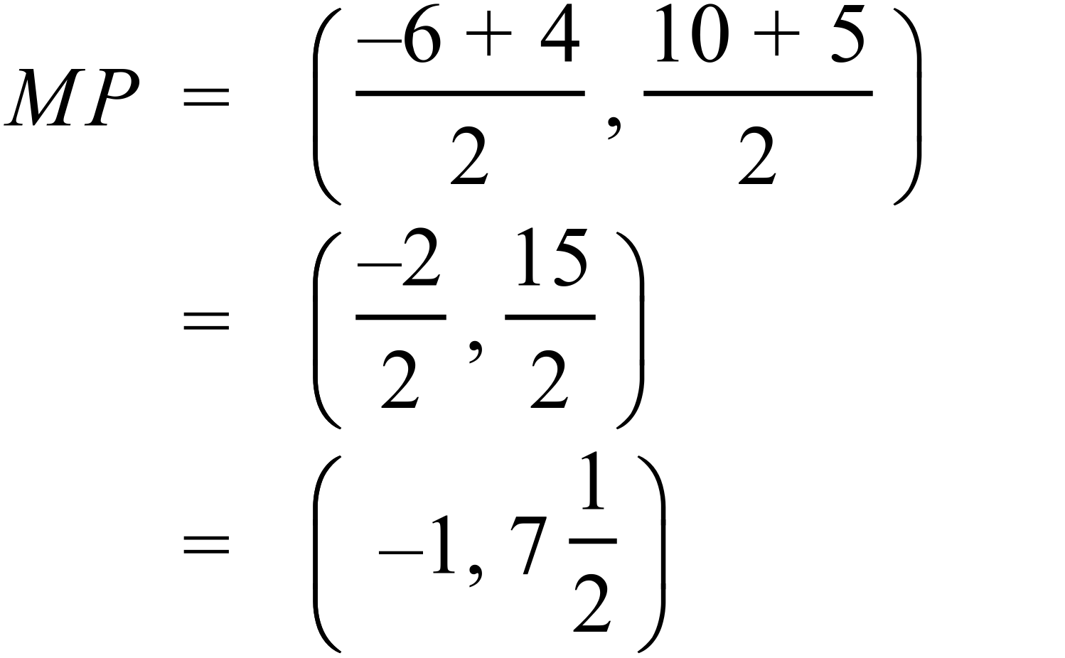 |  | 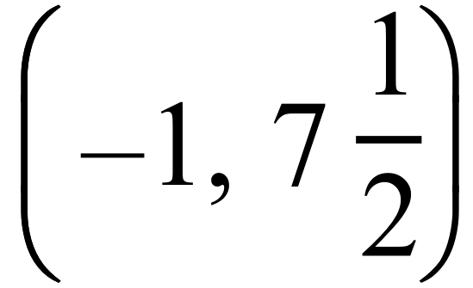
 | 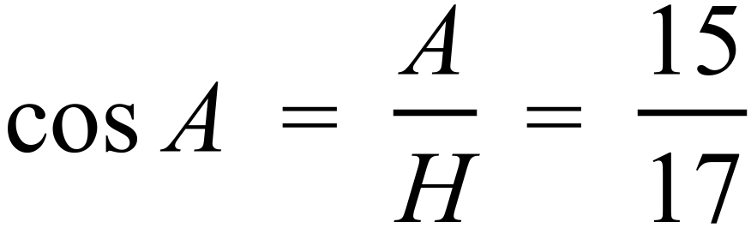 |  | 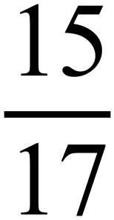
 | 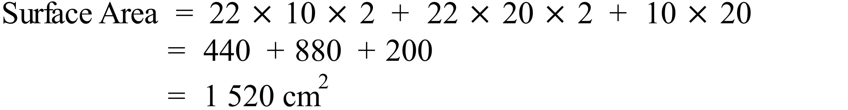 |  | 1 520 cm²
 | 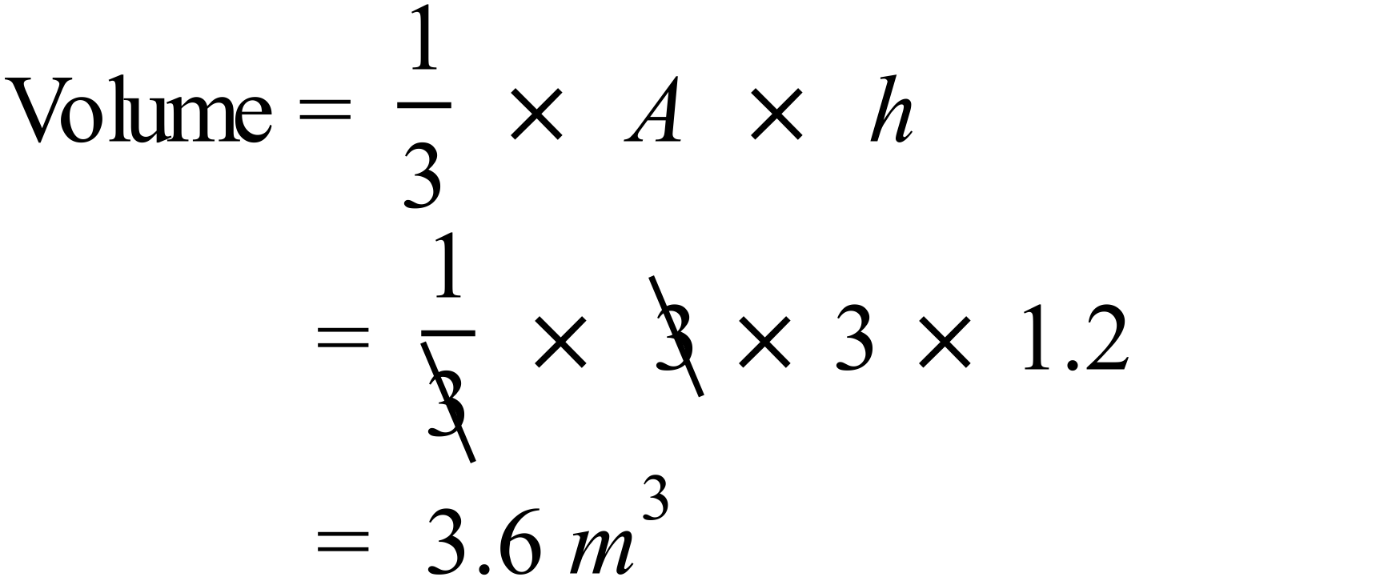 |  | 3.6 m³
 | 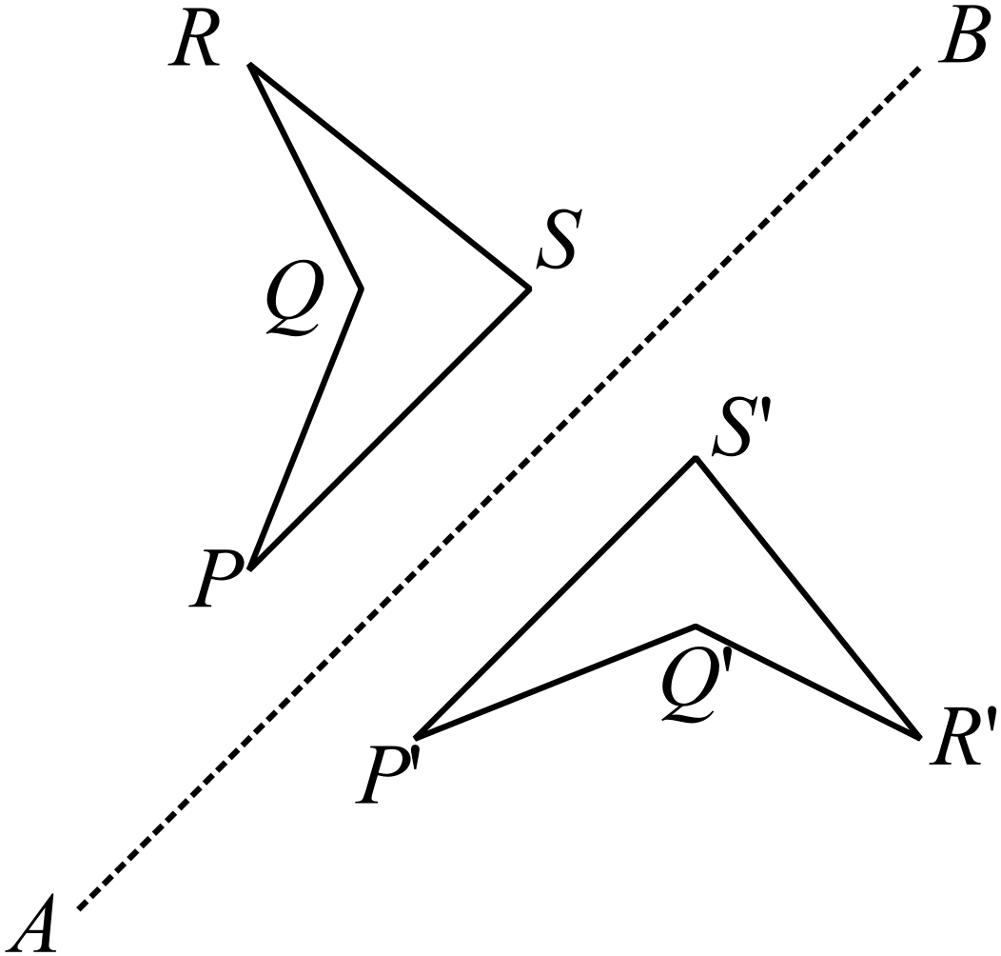 |  | The image P’Q’R’S’ is drawn accurately.
 | 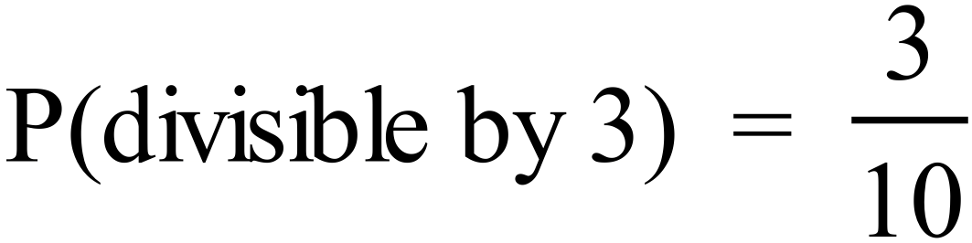 |  | 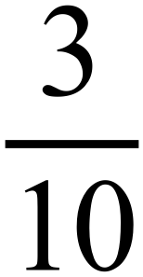
 | 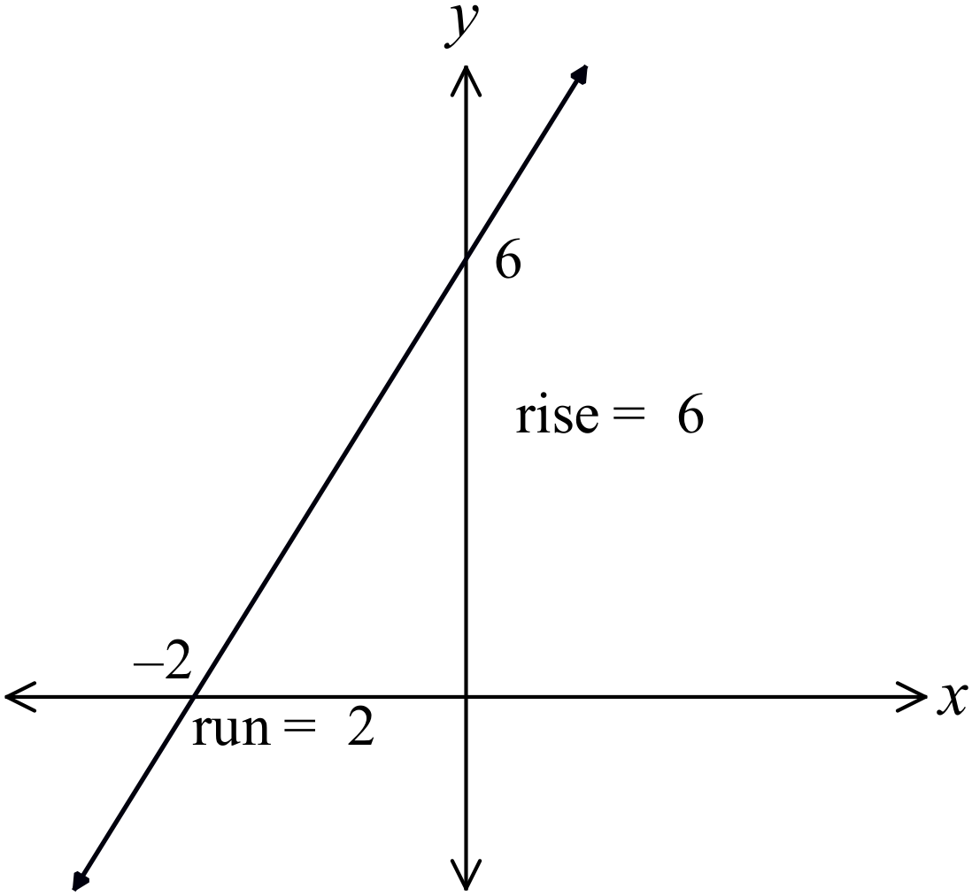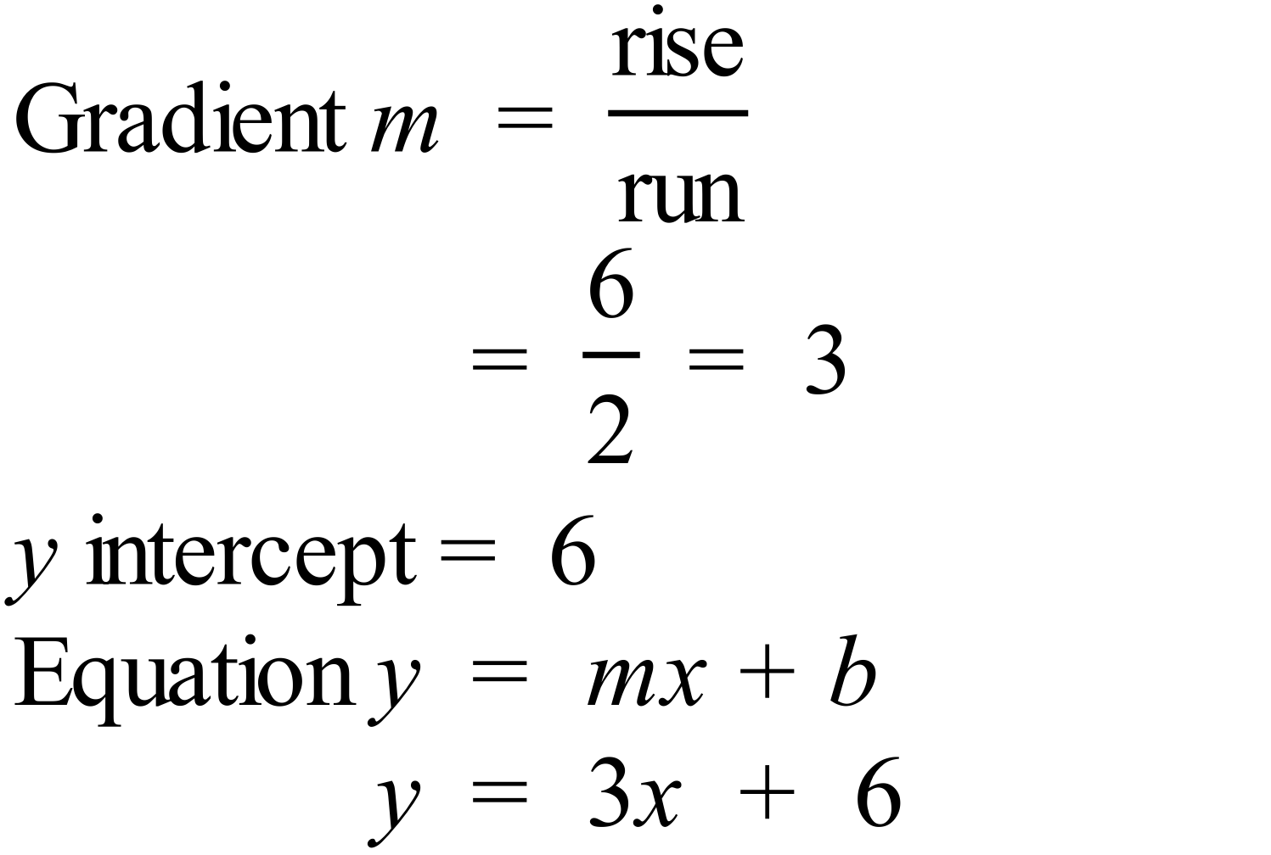 |  | 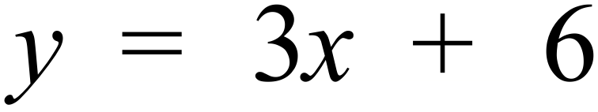
 | 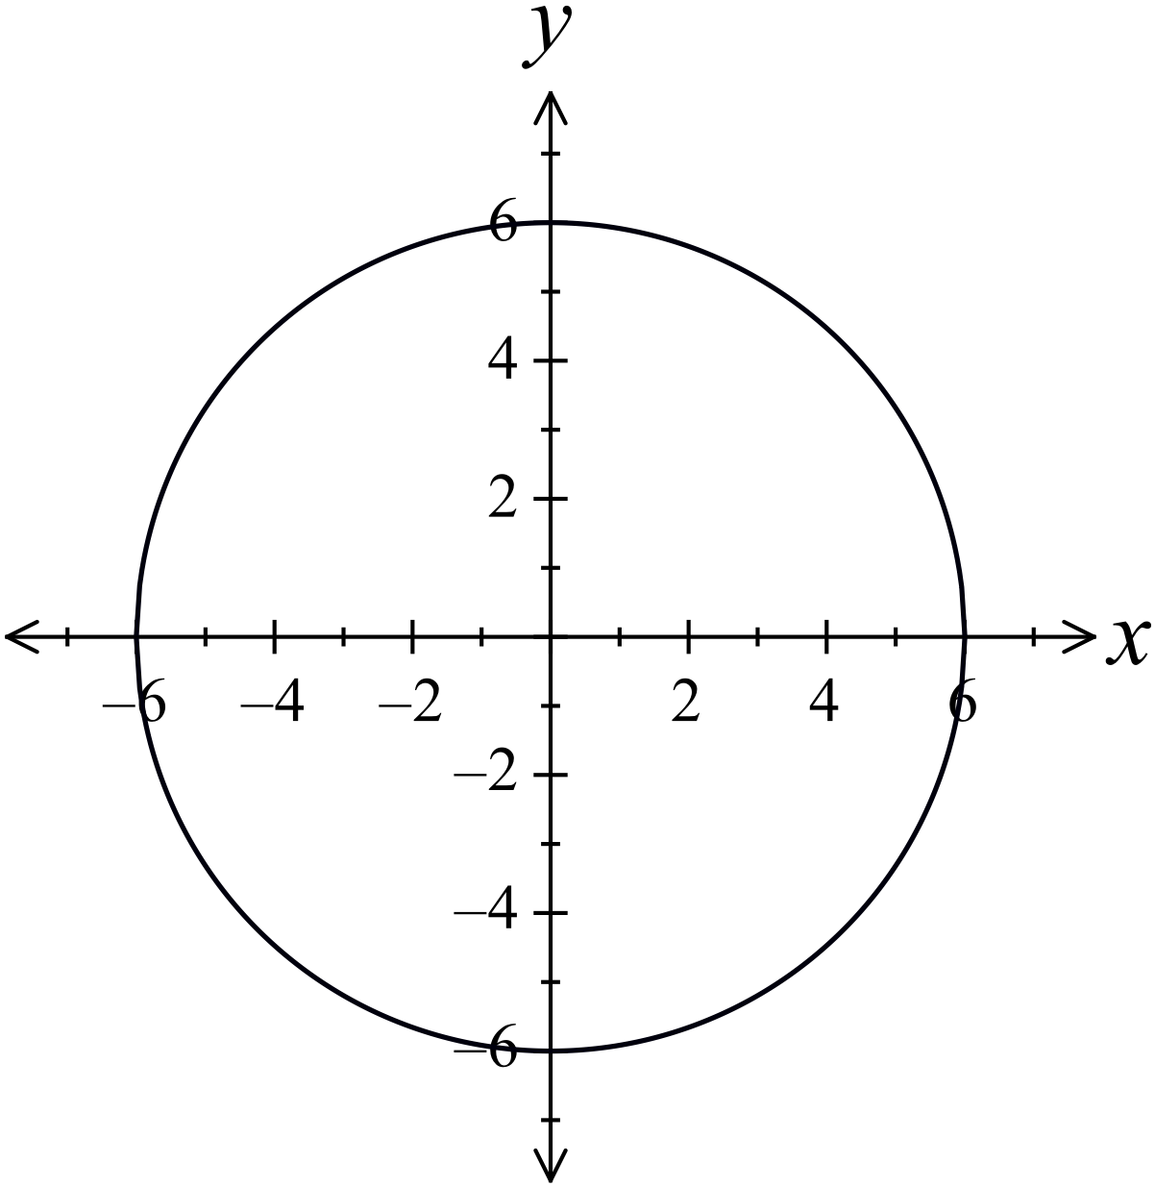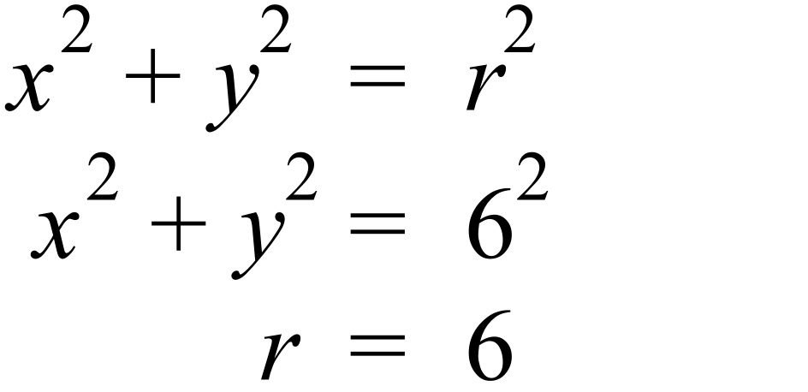  Centre is the origin. |  | See the graph.
 | 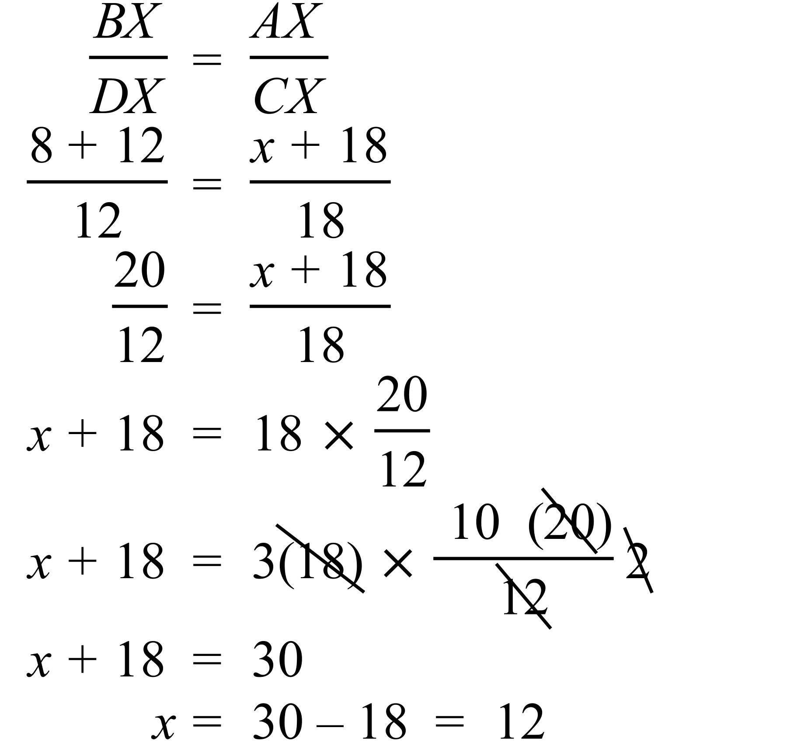 |  | x = 12

Year 10 |  | WME Solutions  Mathematics  Yearly 2016 | Calculator Allowed
Section 2 Part A Multiple Choice Section
ANSWERS
No. | WORKING |  |  | ANSWER
 | 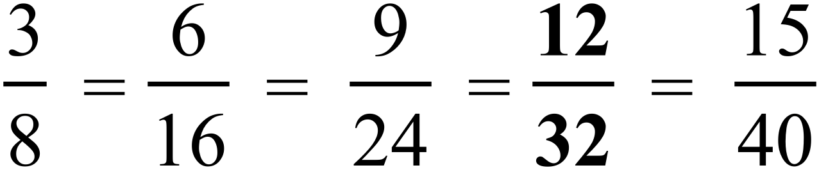 |  |  | D
 | 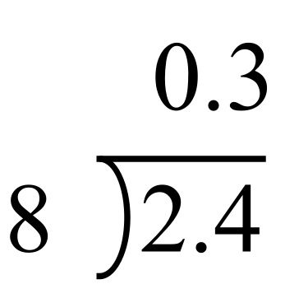 Amount in each glass is 0.3 litres |  |  | B
 | 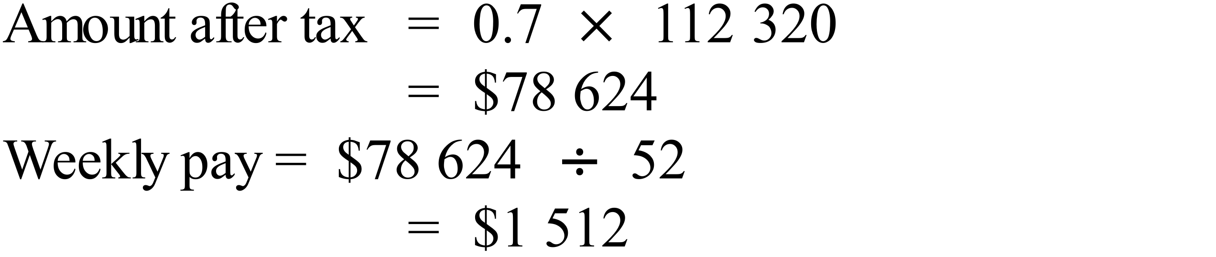 |  |  | B
 | 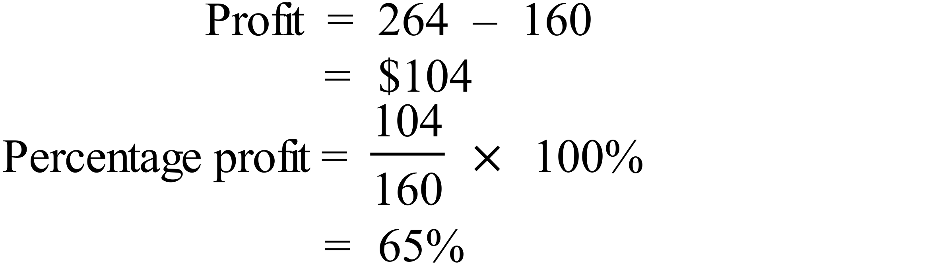 |  |  | C
 |  |  |  | B
   | Kite | Parallelogram | Rectangle | Square
  The diagonals bisect one another. | N | Y | Y | Y
  The diagonals are unequal. | Y | Y | N | N
 | Each side measures 2 metres – 200 cm.  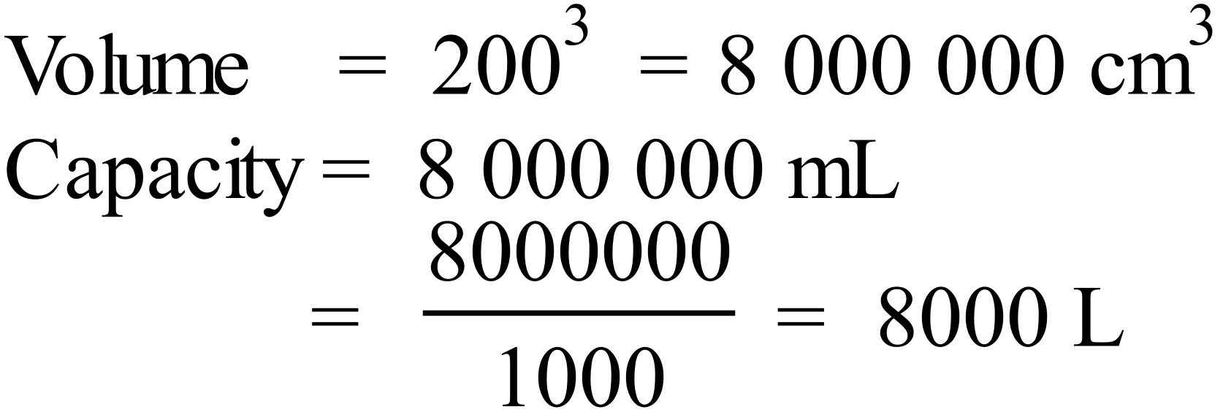 |  |  | C
 | 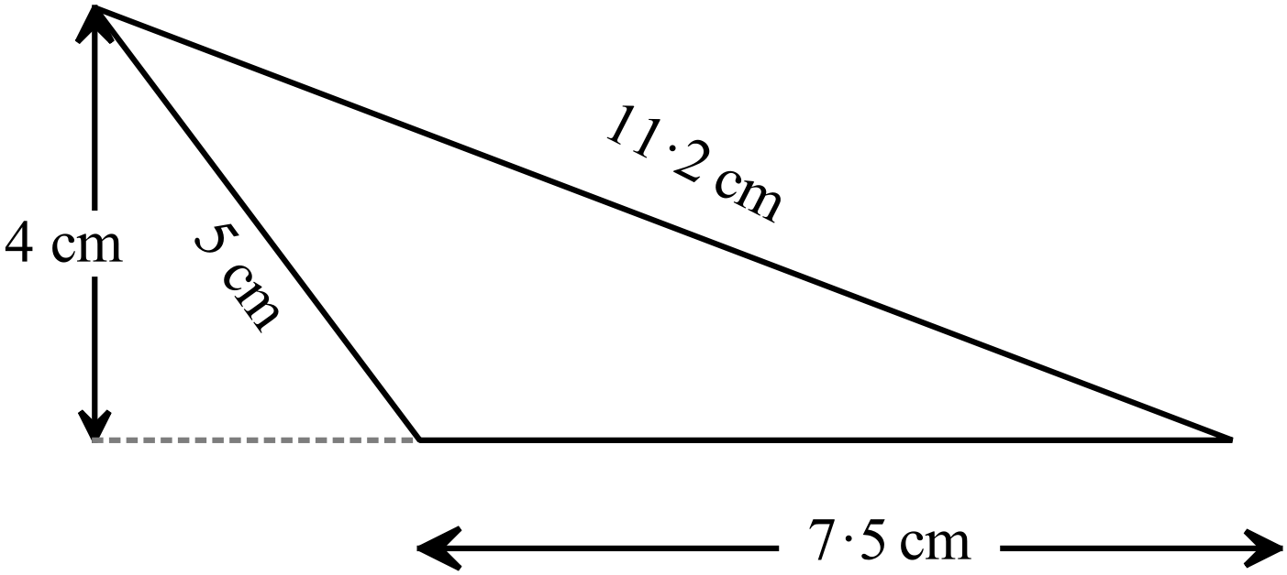  Measurements could be taken in different directions to those shown, as long as the base and height are at right angles to one another.  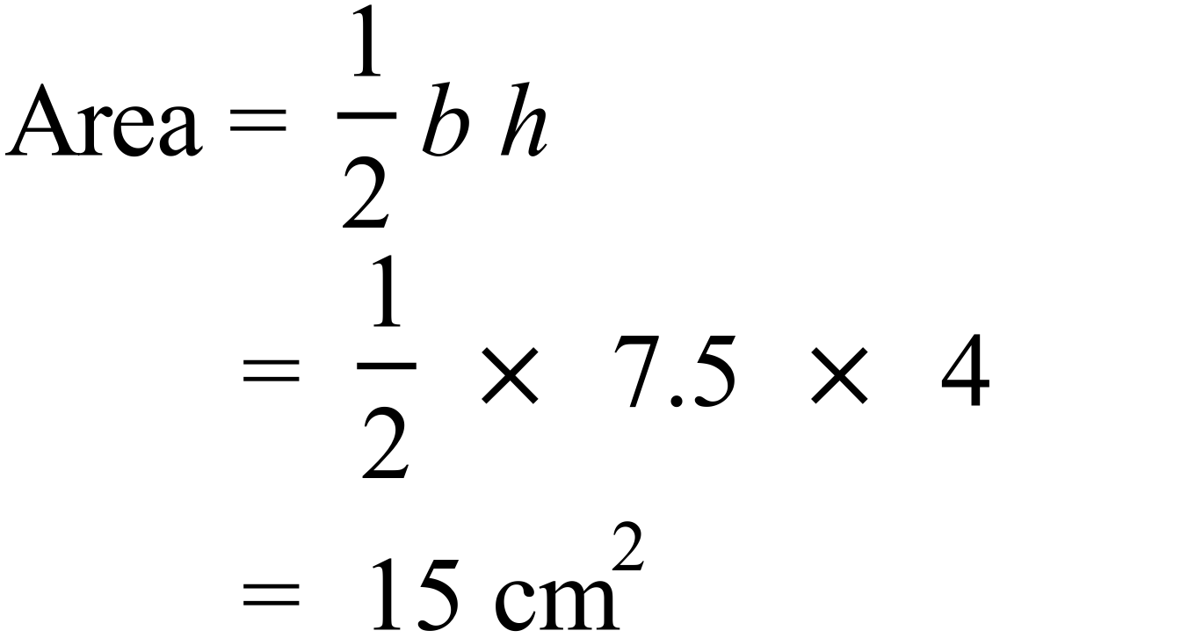 |  |  | B
 |  |  |  | D
 | 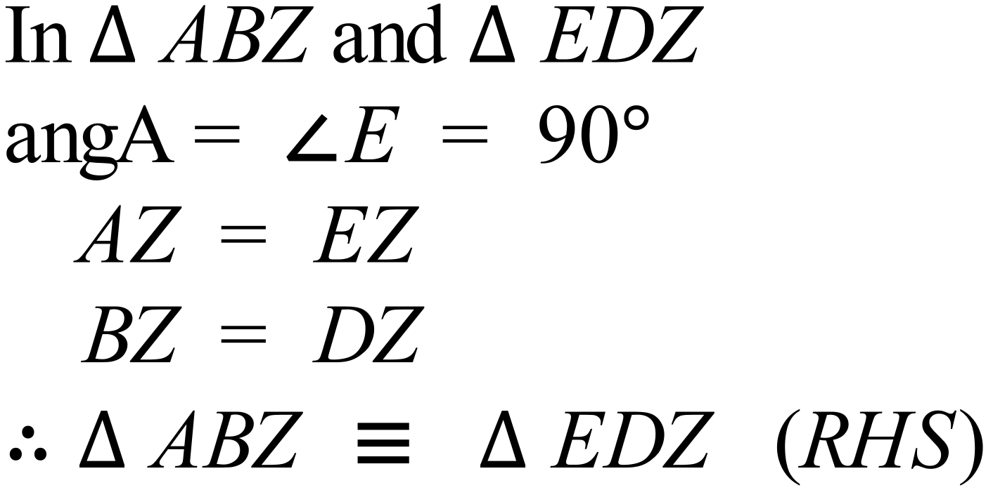 |  |  | A
 |  |  |  | A
 | 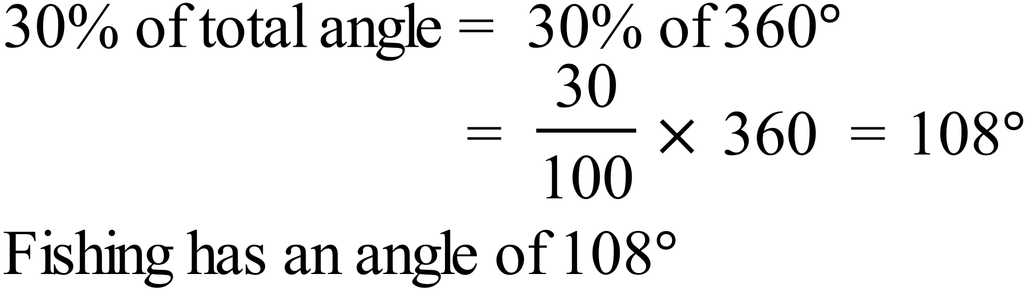 |  |  | A
 | 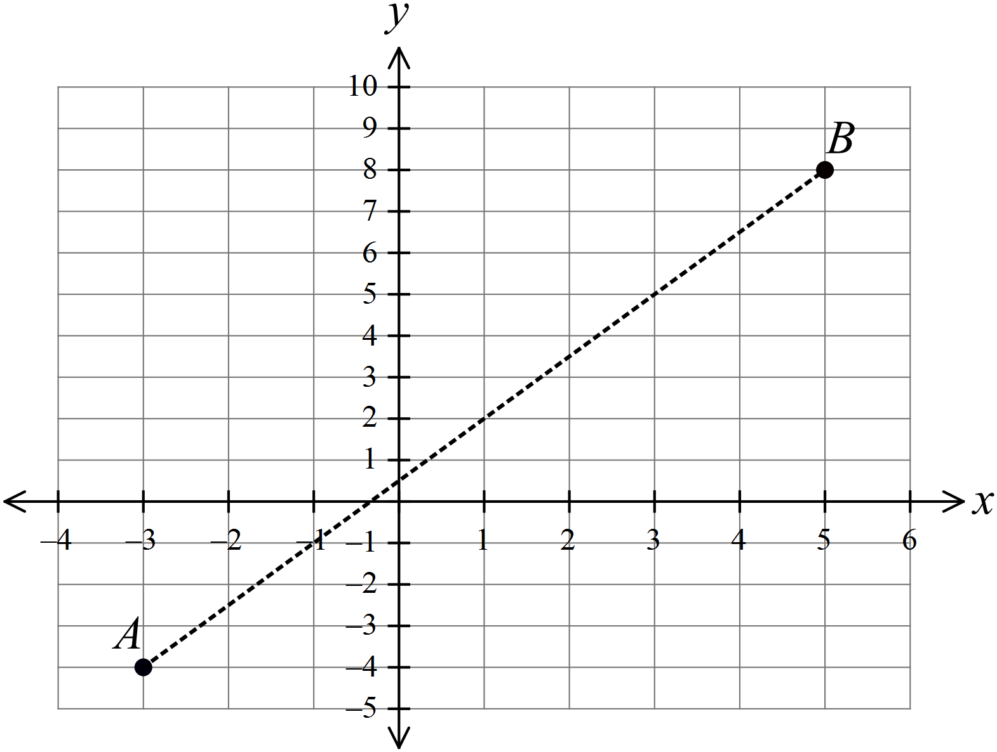  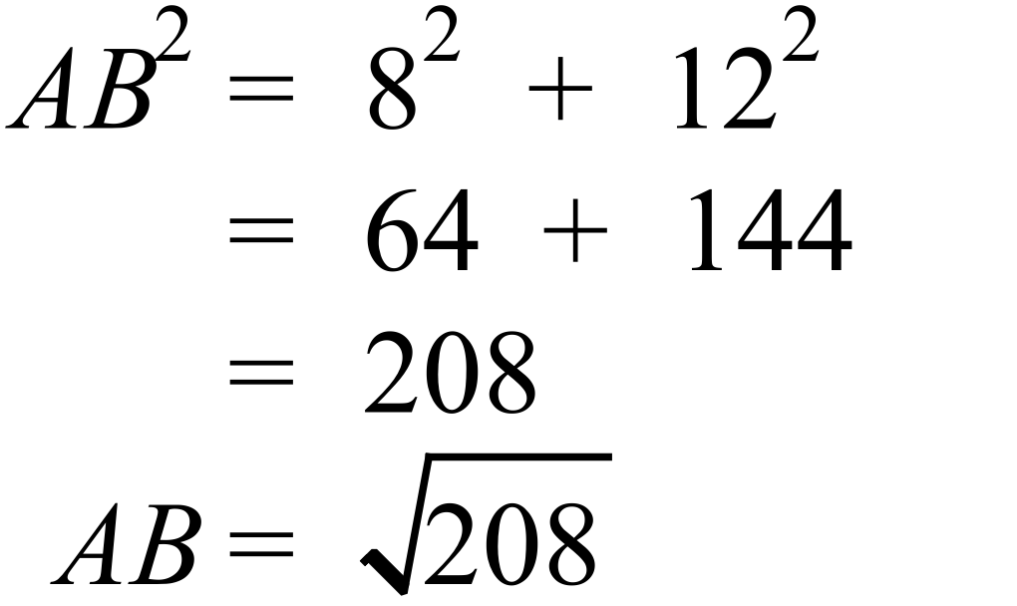 |  |  | D
 | 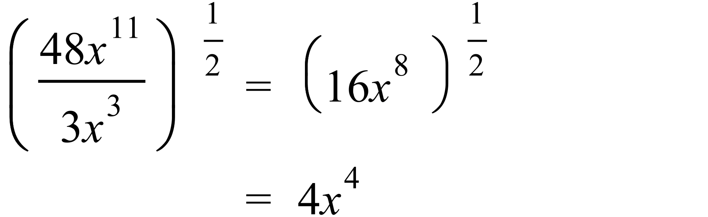 |  |  | B
 | 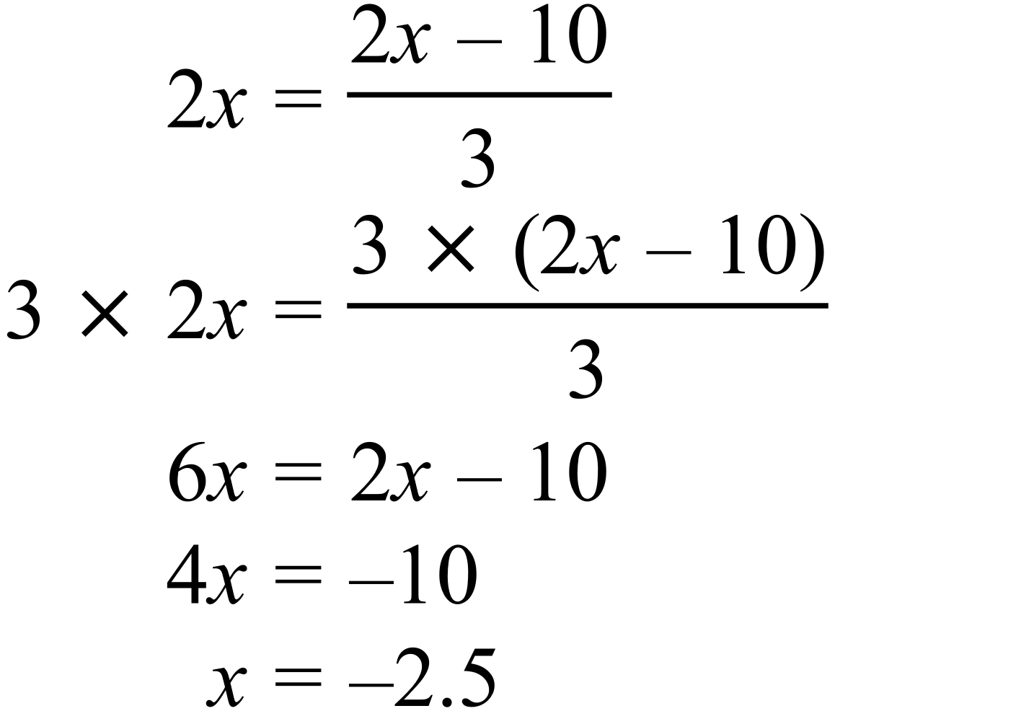 |  |  | B
 | 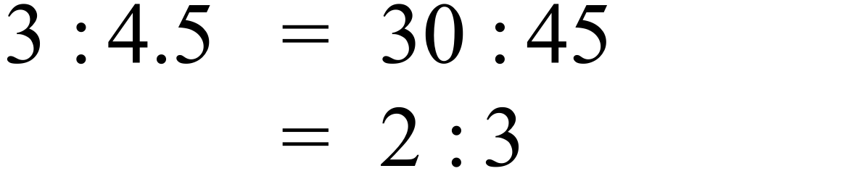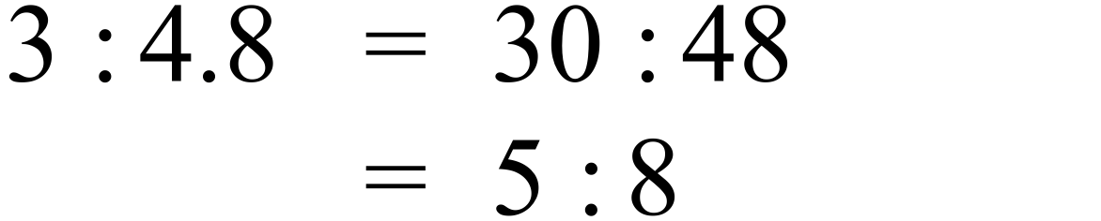  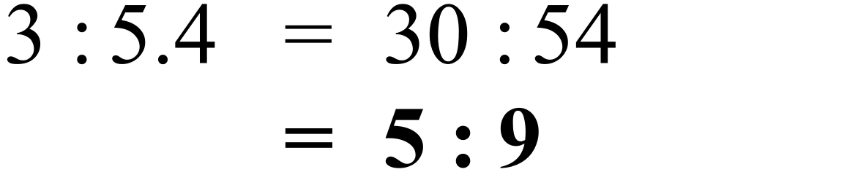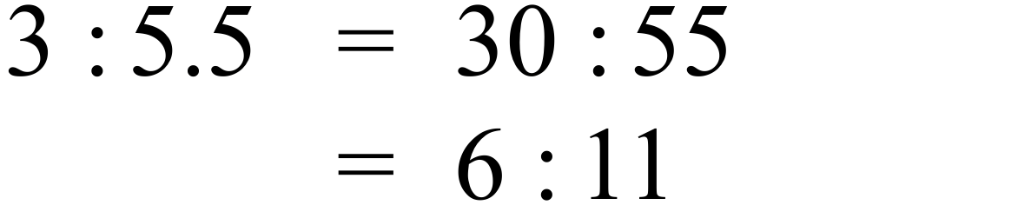 |  |  | C
 | 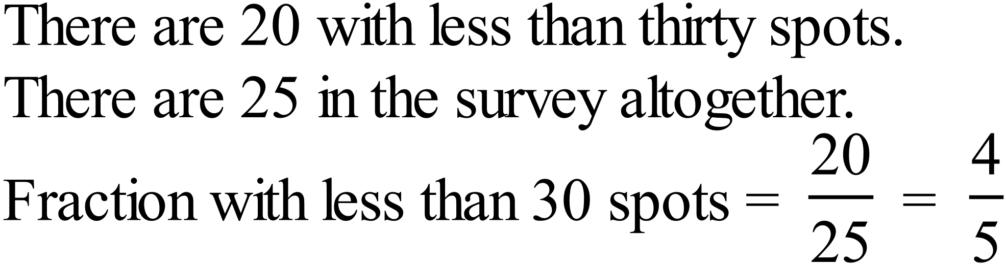 |  |  | D
 | Median = 27 (13th score with 12 above and 12 below)  Lower Quartile = (middle of lower 12 scores so 6th and 7th)  = 26  The median number of spots was 27 and the lower quartile was 26 |  |  | D
   | ⃝
  ⃝ | ⃝ | ⃝ | ⃝ |  | ⃝
  ⃝ | ⃝ | ⃝ | ⃝ | ⃝ | ⃝
  ⃝ | ⃝ | ⃝ | ⃝ | ⃝ | ⃝
  ⃝ | ⃝ | ⃝ | ⃝ | ⃝ | ⃝ | ⃝
  25 | 26 | 27 | 28 | 29 | 30 | 31
  Number of Spots
 | 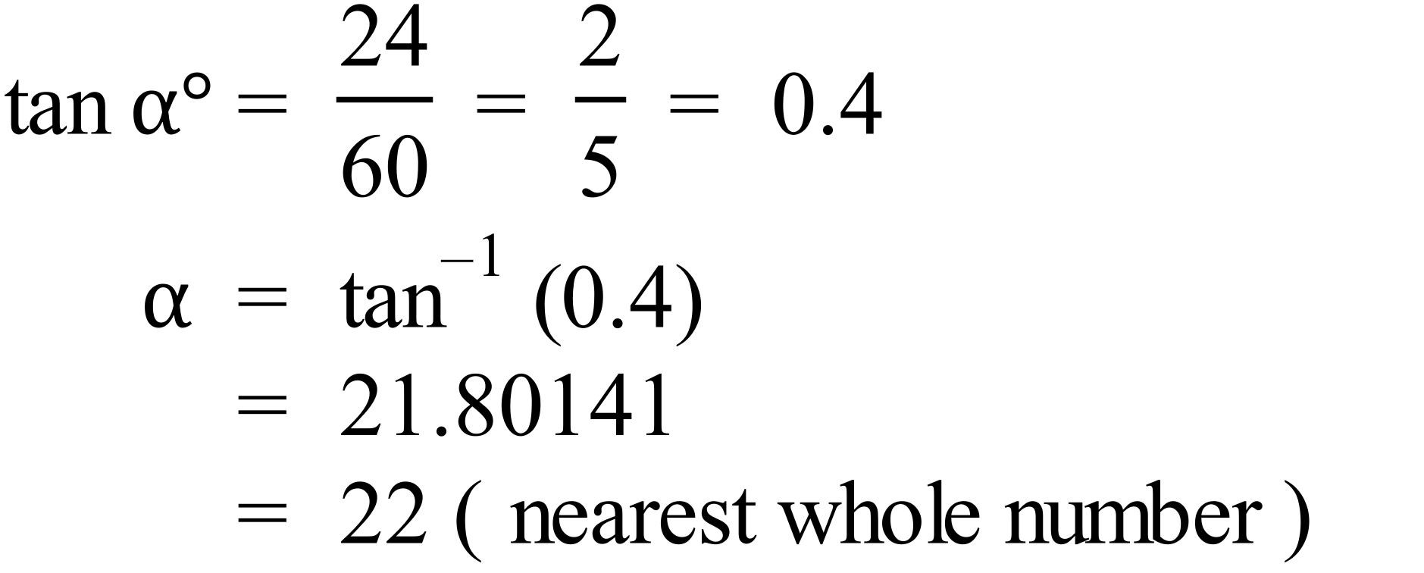 |  |  | A
 | 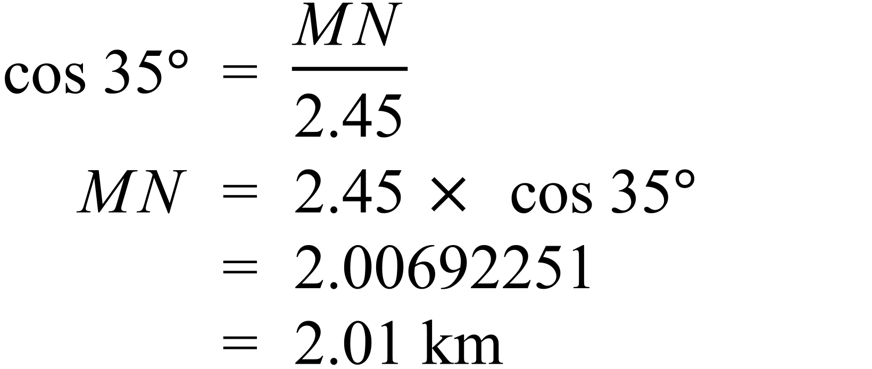 |  |  | C
 | 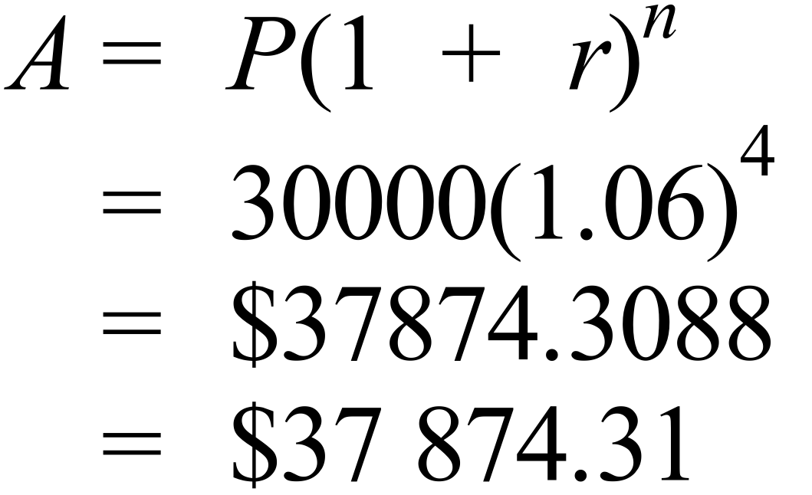 |  |  | D
 | 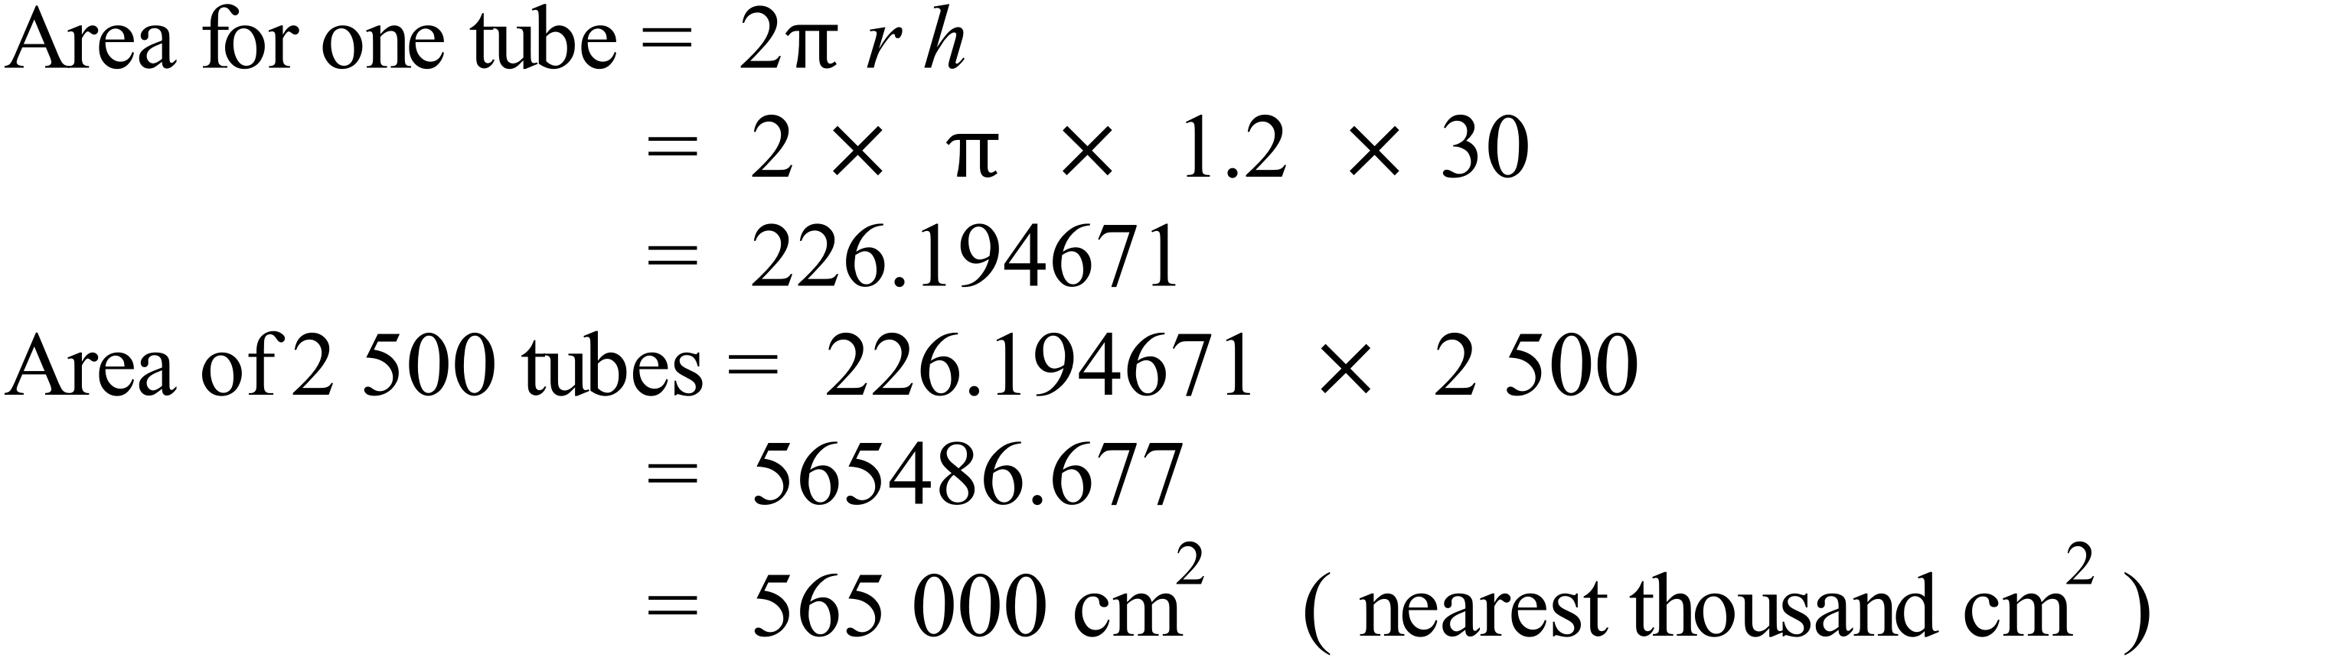 |  |  | C
 | 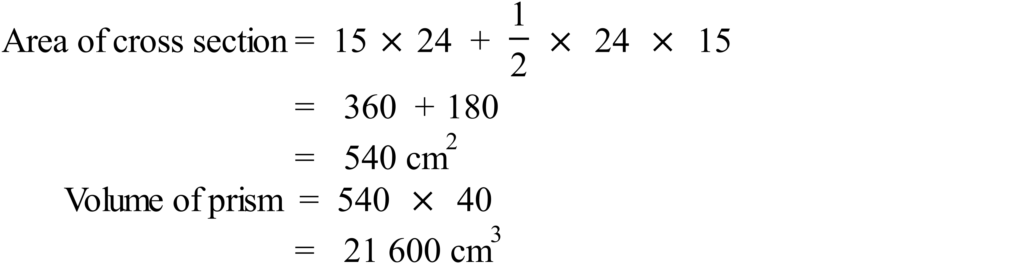 |  |  | C
 | There are 13 letters in OPPORTUNITIES.  There are 2 O’s and 1 U.  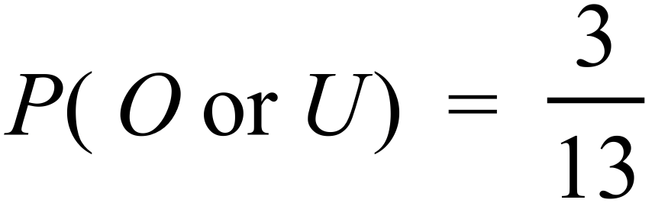 |  |  | C
 | A pair of similar triangles are formed.  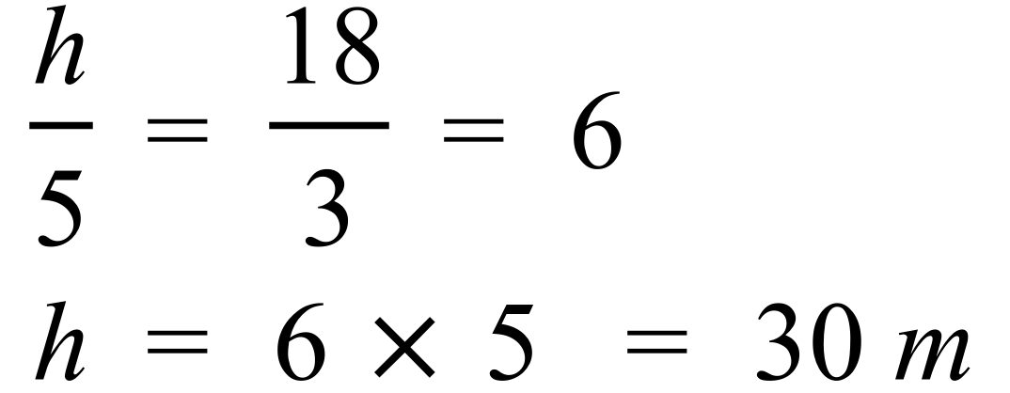 |  |  | D
 | She was away from home for 11.5 hours (7 before midday and 4.5 after)  She stopped for half an hour on the way and was at the appointement for 2 hours a total of 2.5 hours.  Time driving = 11.5 – 2.5 = 9 hours |  |  | A
 | 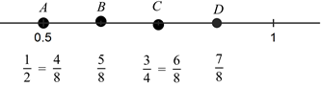 |  |  | B
 | 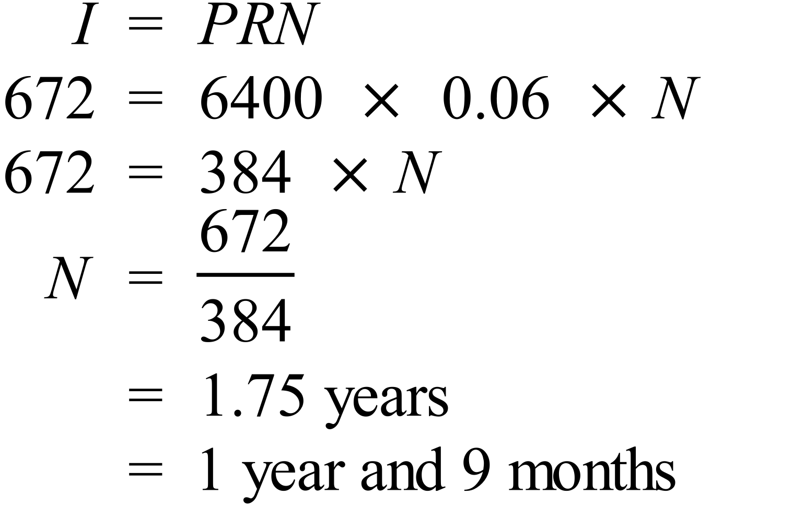 |  |  | B
 | 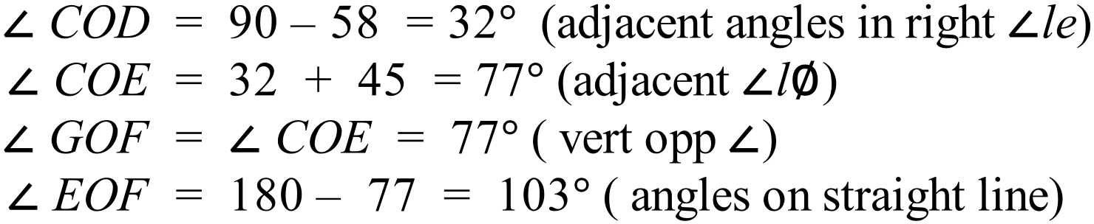  OTHER POSSIBLE REASONING |  |  | A
 | 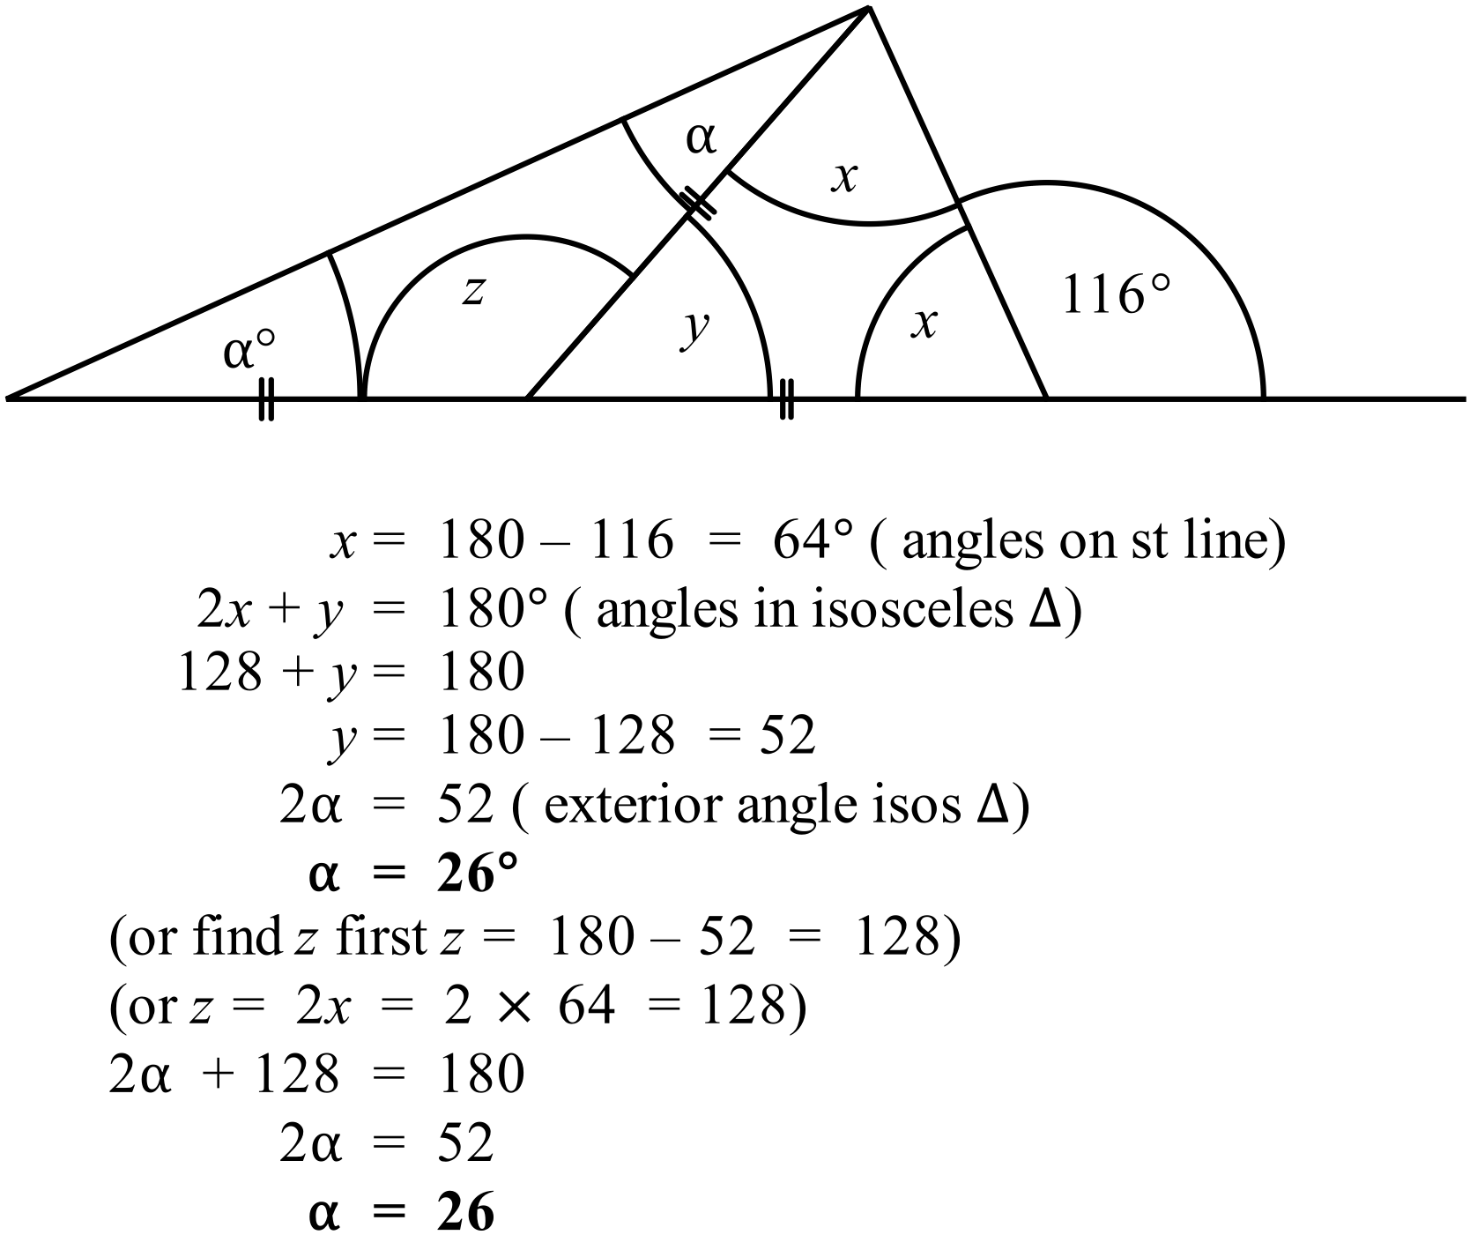 |  |  | B
 | 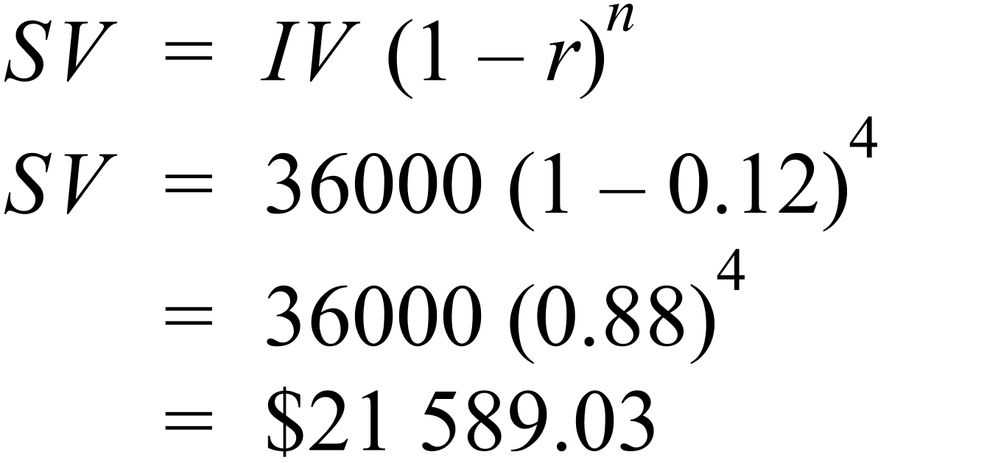 |  |  | B
 |  |  |  | D
 | 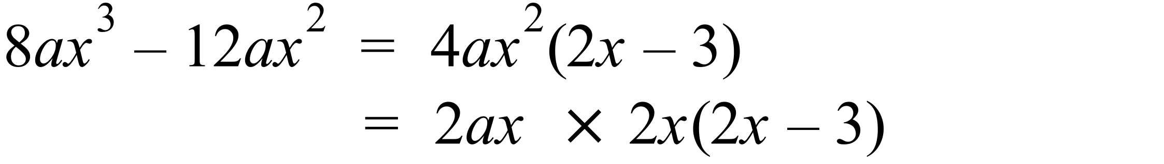 |  |  | A
 | 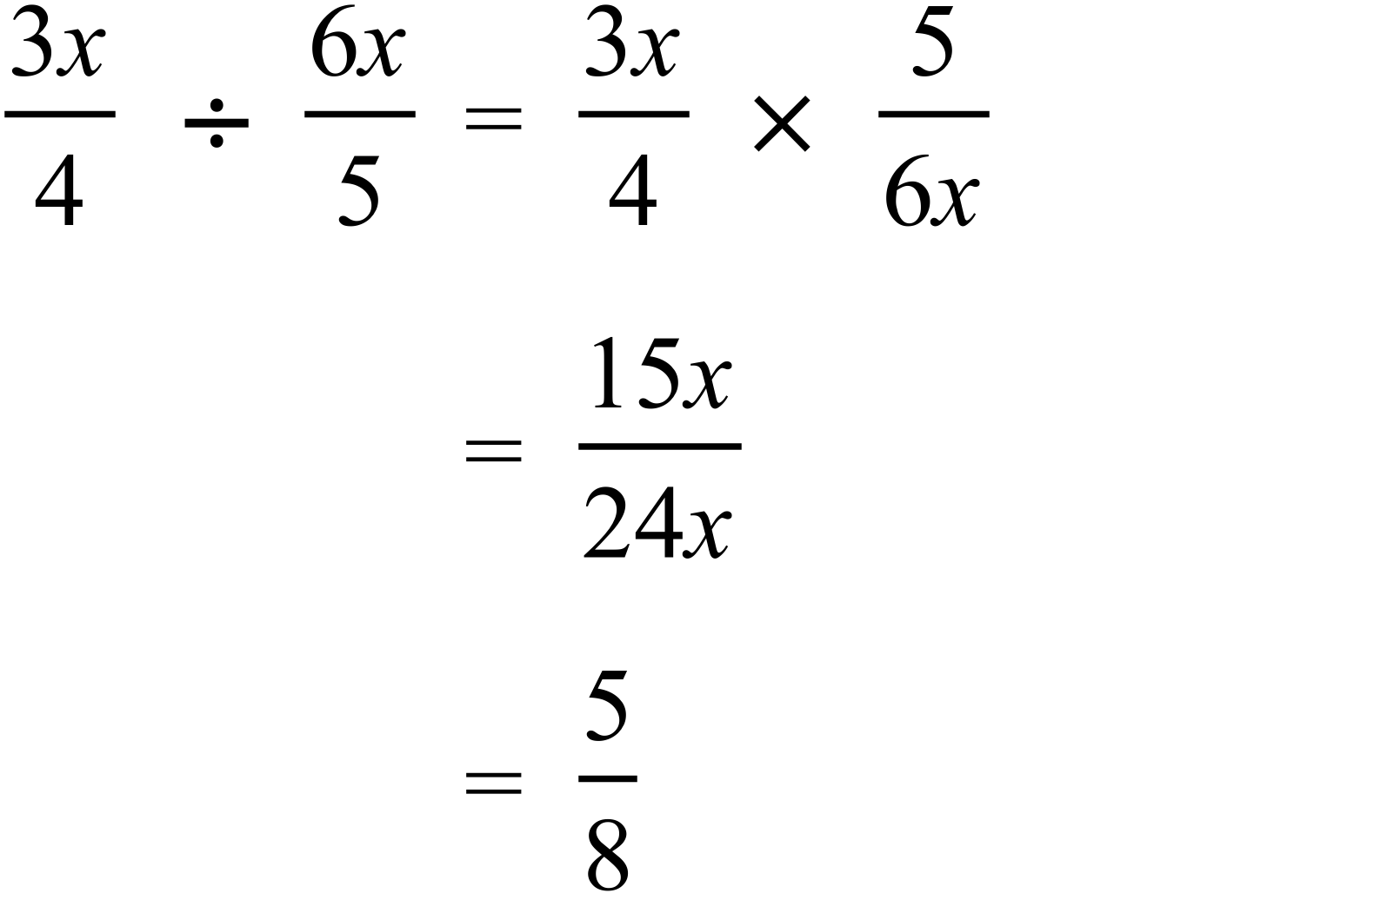 |  |  | A
 | 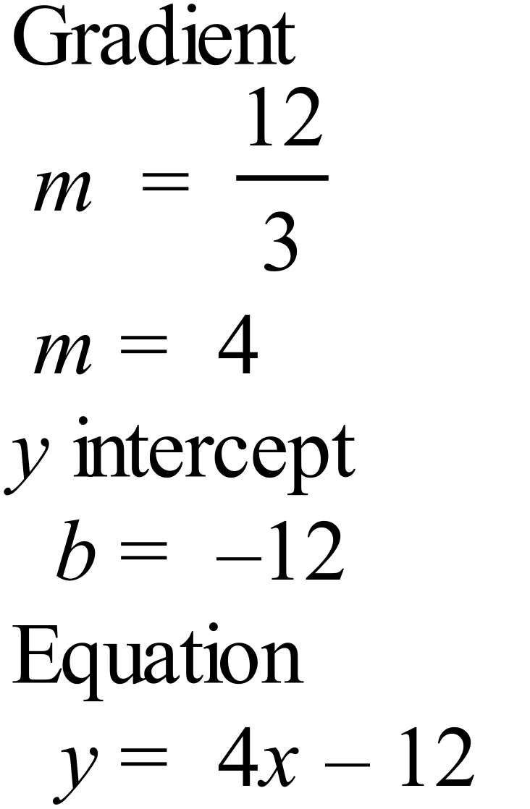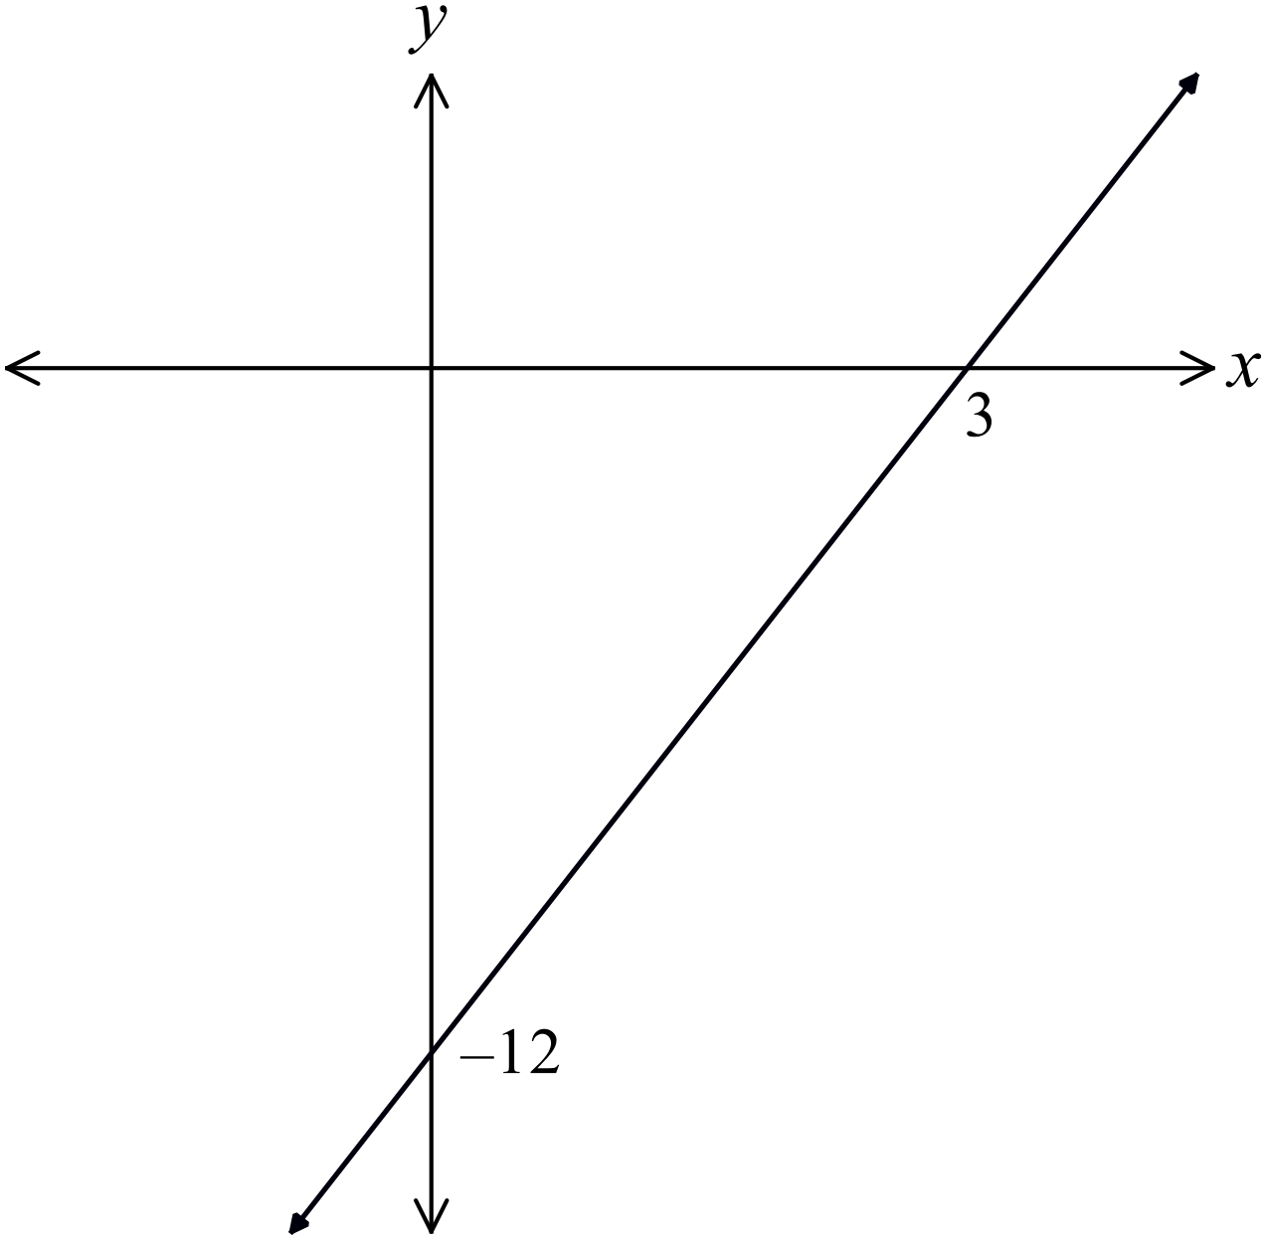 |  |  | D
 | 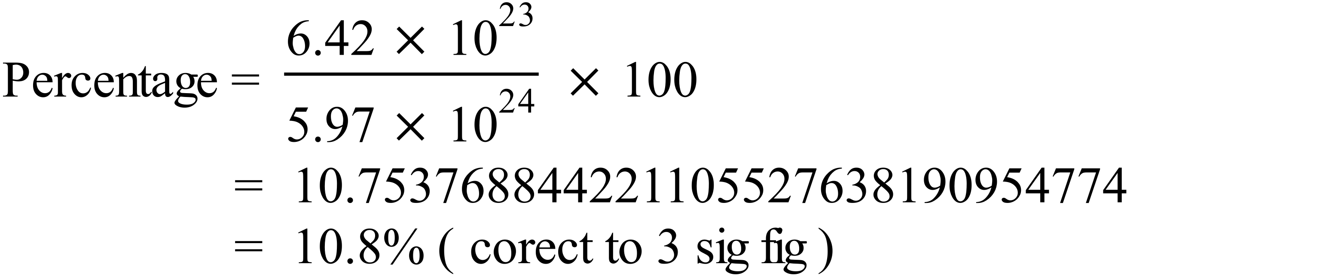 |  |  | A
 | 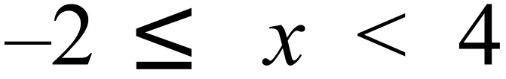  -2 is included, so is shaded and 4 is not so is not shaded, and x lies between these two, so the line joins -2 and 4. |  |  | B
 | 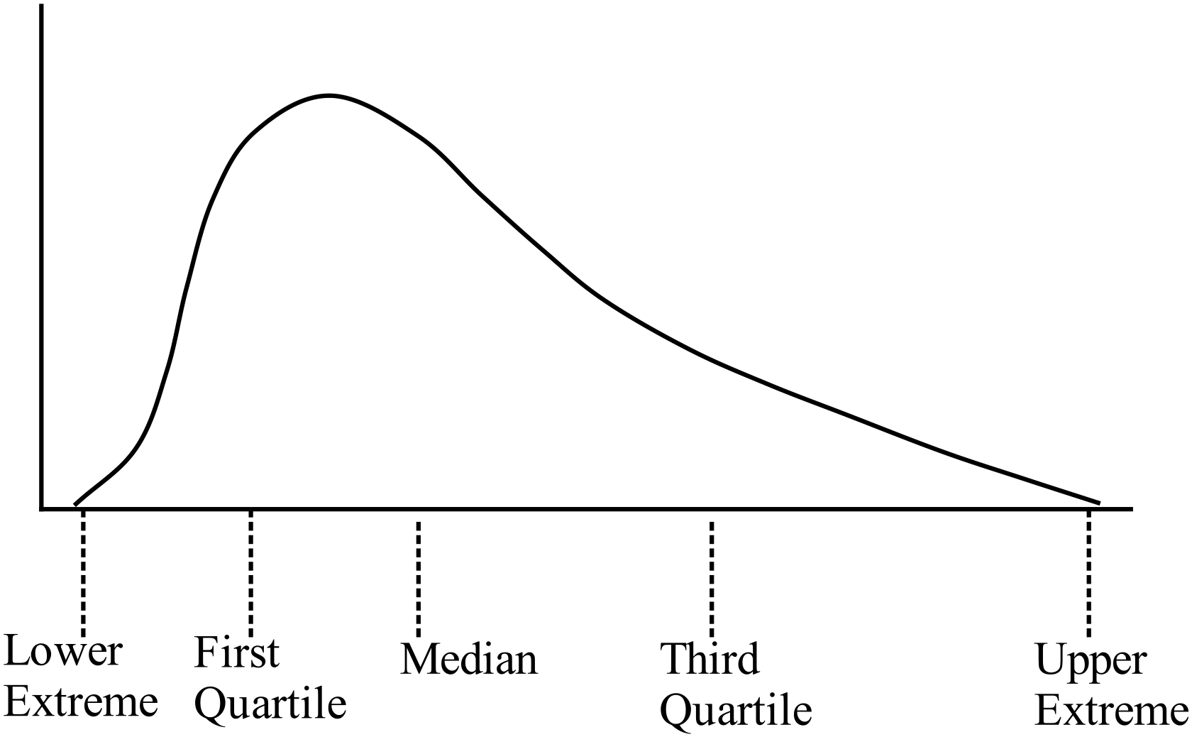As the lower quartile, lower extreme and median are more closely groups than the upper quartile and upper extreme, the scores are more bunched toward the lower values, so the tail is toward the top, so it is positively skewed. |  |  | C
 | 67 is the first quartile, so three-quarters of the scores will be equal or higher.  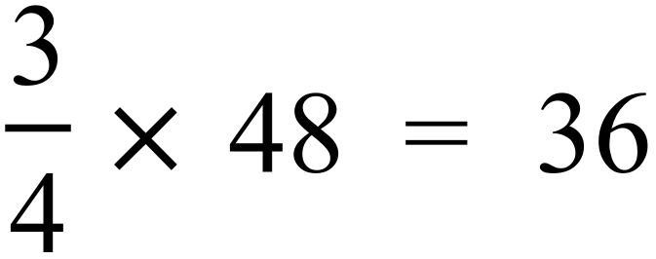 |  |  | D
 | 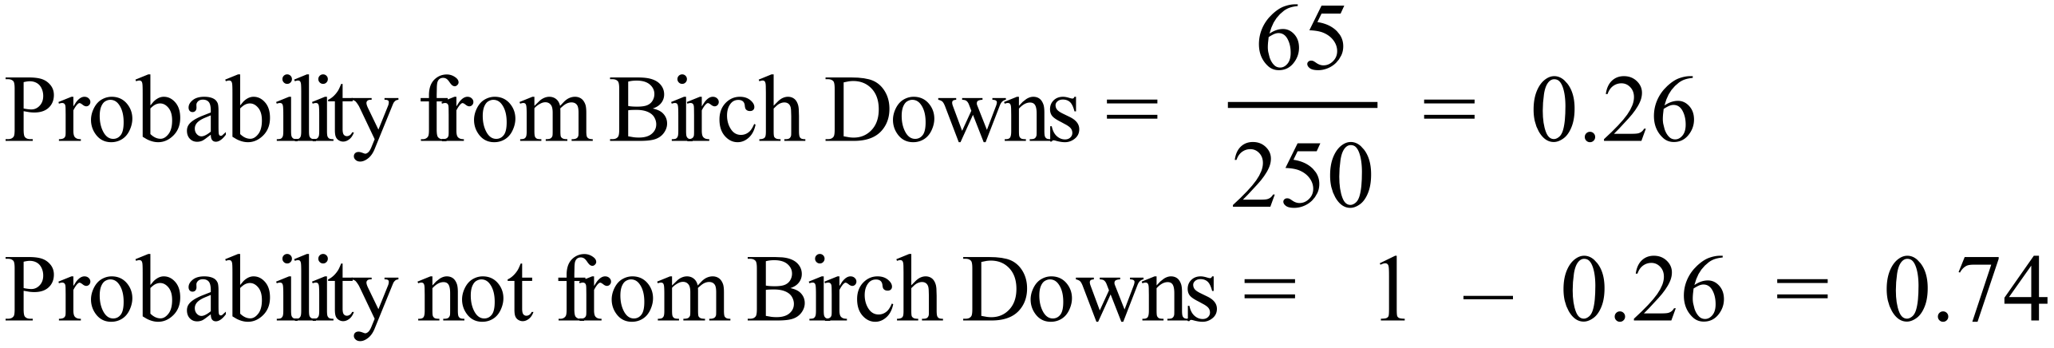 |  |  | C
 | Bearing of Daedalus = 270º – 34º = 236º |  |  | D
 | 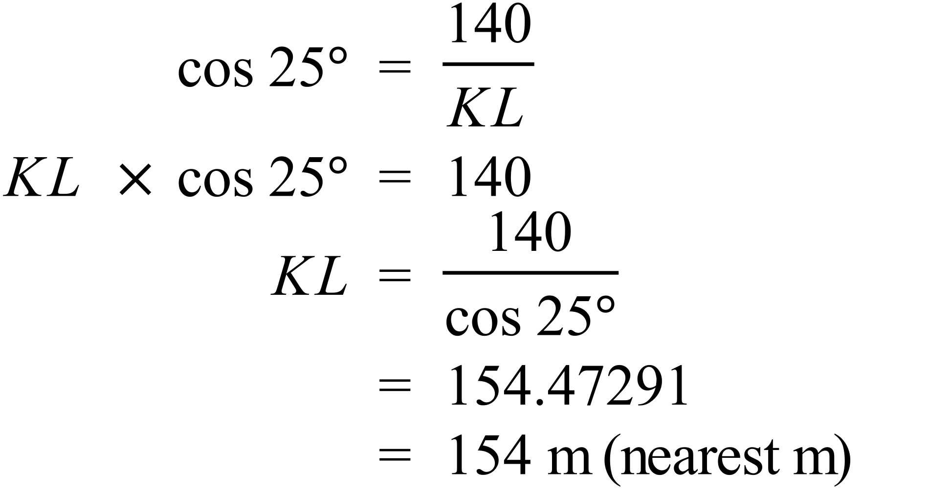 |  |  | A
 | 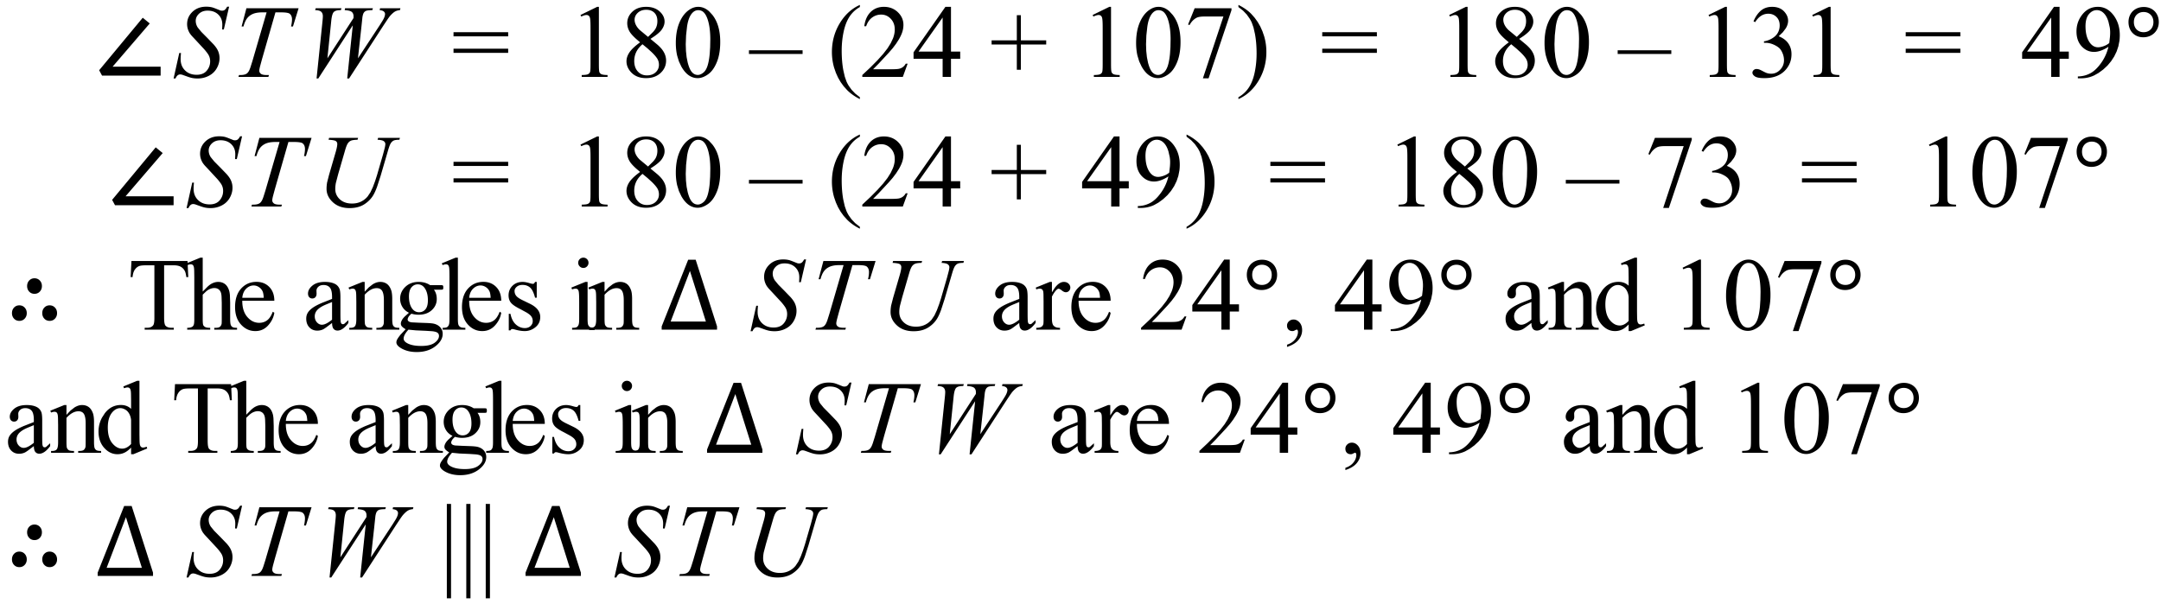 |  |  | A
 | 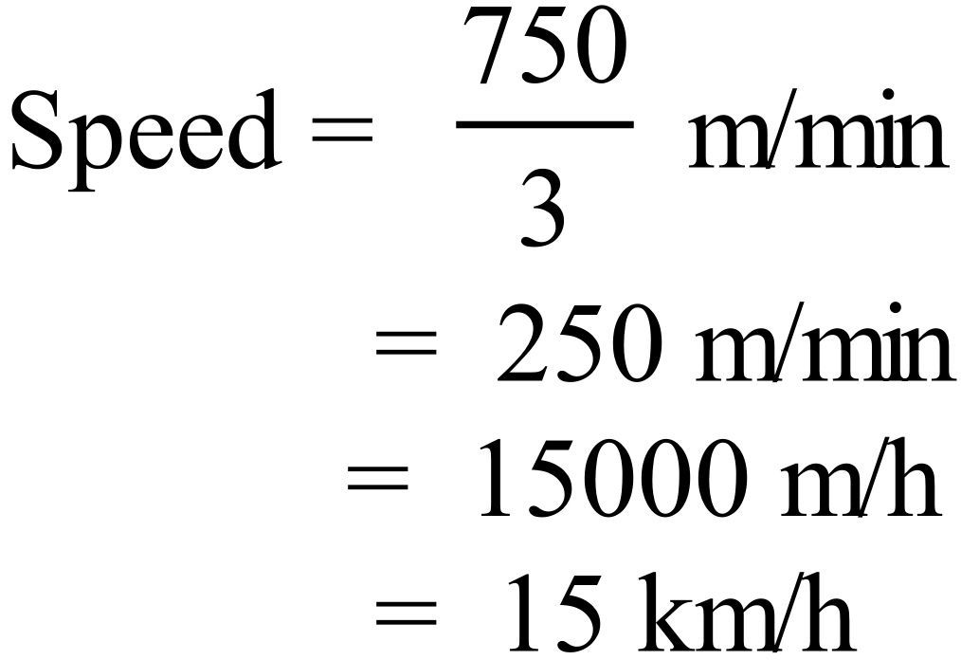 |  |  | D
 | Interest rate = 7.2% pa = 0.6% per month  Period = 4 years = 48 months  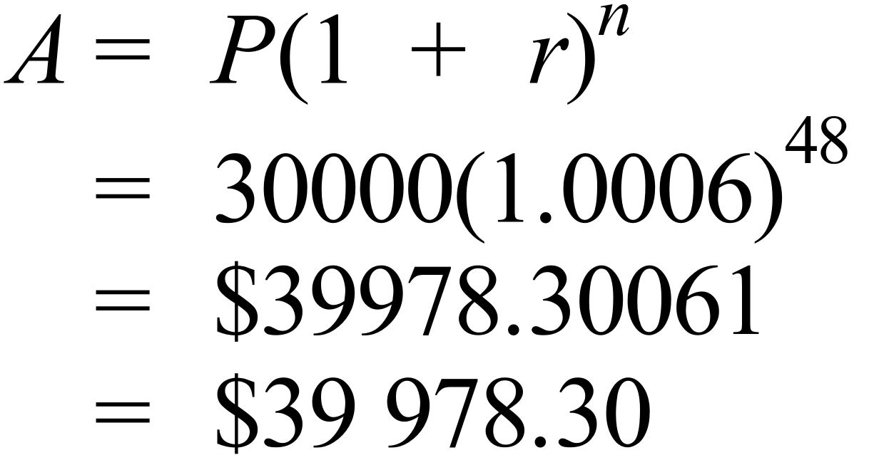 |  |  | C
 | 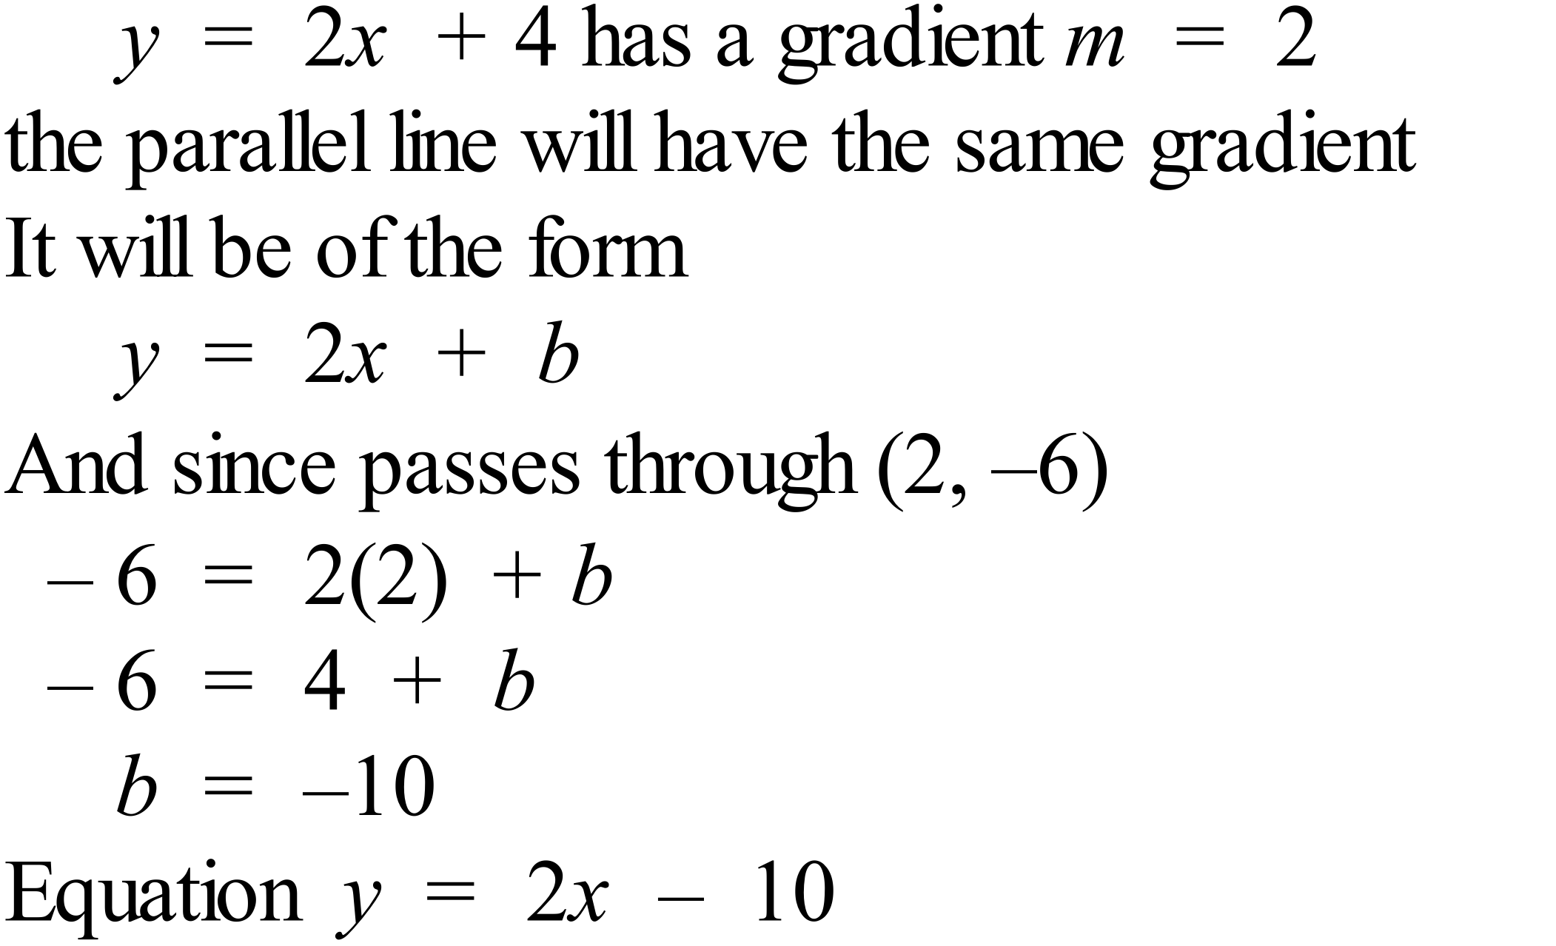 |  |  | C
 | 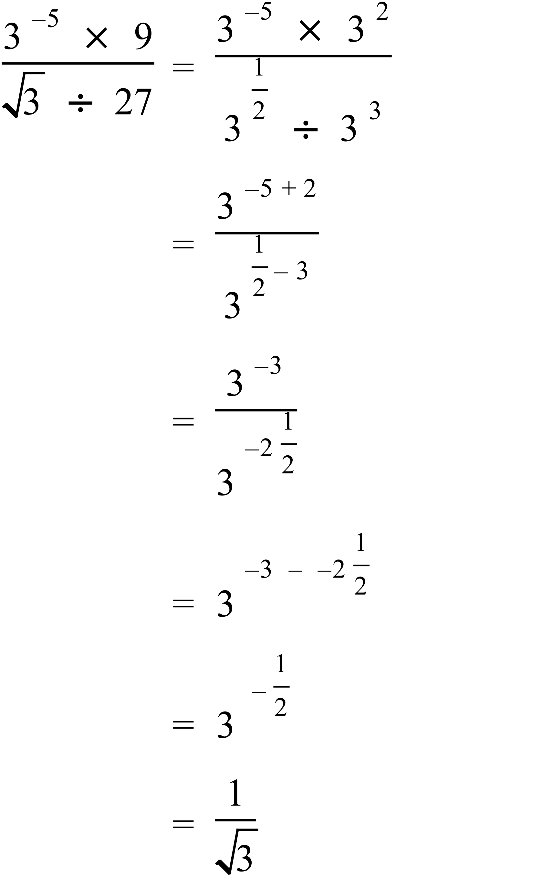 |  |  | B
 | 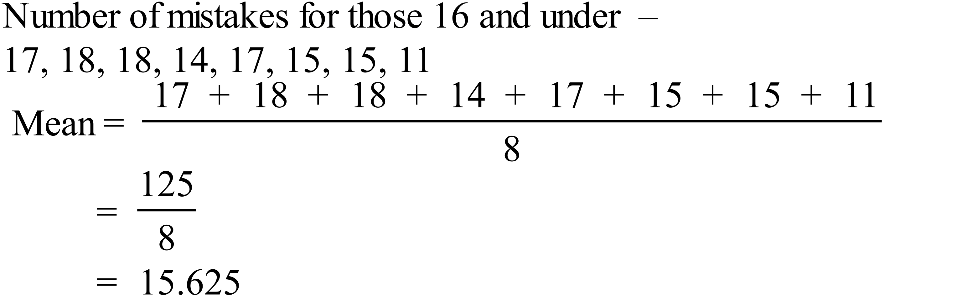 |  |  | D
 | The dots on the graph quite clearly follow a linear shape (straight line) so it is a strong relationship, and the number of mistakes decreases as the age increases so the relationship is negative.  So there is a strong negative relationship between age and number mistakes. |  |  | A
 | The graph has a y intercept of about 11, so only B and D have this.  The graph is exponential so equation is B 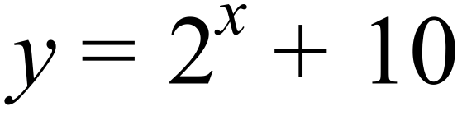  Or by testing a second point  e.g. when x = 6  B. 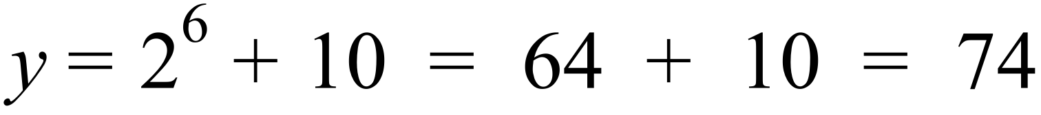  D. 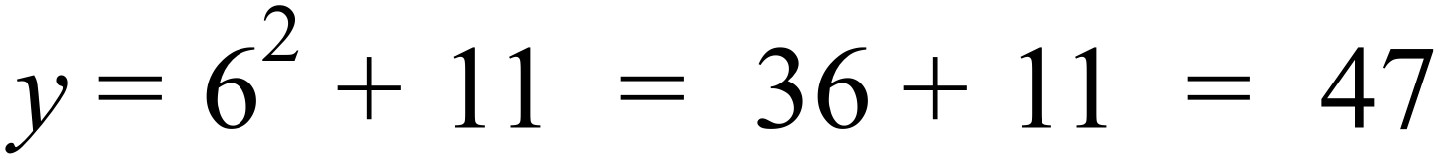  On Graph, when x = 6, y = 74 so correct graph is B. |  |  | B
 | 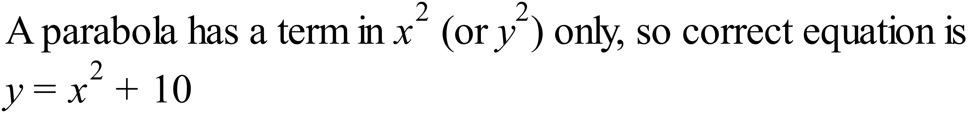 |  |  | C

School Name
Year 10 Mathematics Examination
Solutions 2016
Multiple Choice Section Answer Sheet

Name _______Marking Sheet________ Teacher ________________________

Completely fill the response oval representing the most correct answer.
Use a black or blue pen or 2B pencil.

26. A B C D
27. A B C D
28. A B C D
29. A B C D
30. A B C D
31. A B C D
32. A B C D
33. A B C D
34. A B C D
35. A B C D
36. A B C D
37. A B C D
38. A B C D
39. A B C D
40. A B C D
41. A B C D
42. A B C D
43. A B C D
44. A B C D
45. A B C D
46. A B C D
47. A B C D
48. A B C D
49. A B C D
50. A B C D

51. A B C D
52. A B C D
53. A B C D
54. A B C D
55. A B C D
56. A B C D
57. A B C D
58. A B C D
59. A B C D
60. A B C D
61. A B C D
62. A B C D
63. A B C D
64. A B C D
65. A B C D
66. A B C D
67. A B C D
68. A B C D
69. A B C D
70. A B C D
71. A B C D
72. A B C D
73. A B C D
74. A B C D
75. A B C D

Year 10 |  |  | WME Solutions  Mathematics  Yearly 2016 | Calculator Allowed
Section 2 Part B Longer Answer Section
ANSWERS
 |  |  |  |  | Marks
76. | a) | There are 21 scores, so 21 players |  |  | 1 mark for correct answer
 | b) | The sum of the scores = 1029  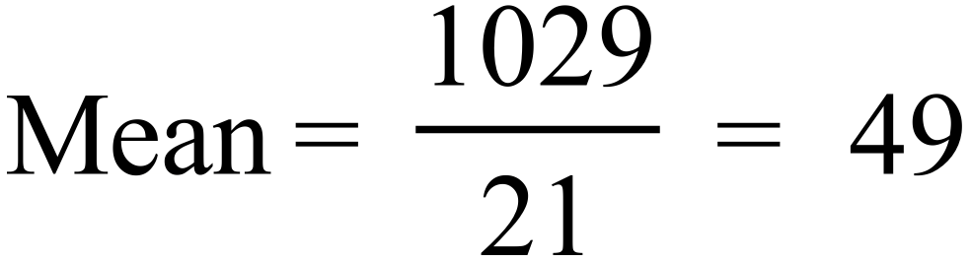 |  |  | 1 mark for correct answer
 | c) | Median is the 11th score (10 above and 10 below)  Median = 48 |  |  | 1 mark for correct answer
 | d) | Lower quartile = 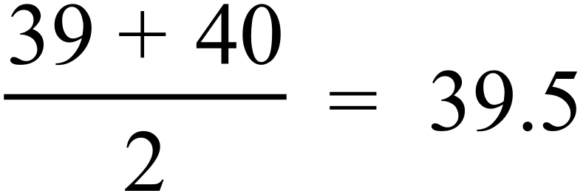 (5th and 6th scores)  Upper quartile = 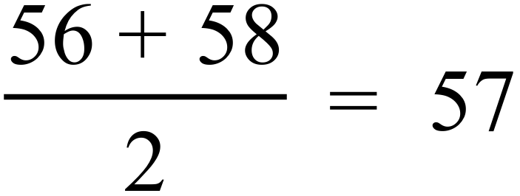 (16th and 17th scores)  Interquartile range = 57 – 39.5 = 17.5 |  |  | 1 mark for correct answer
77. | a) | 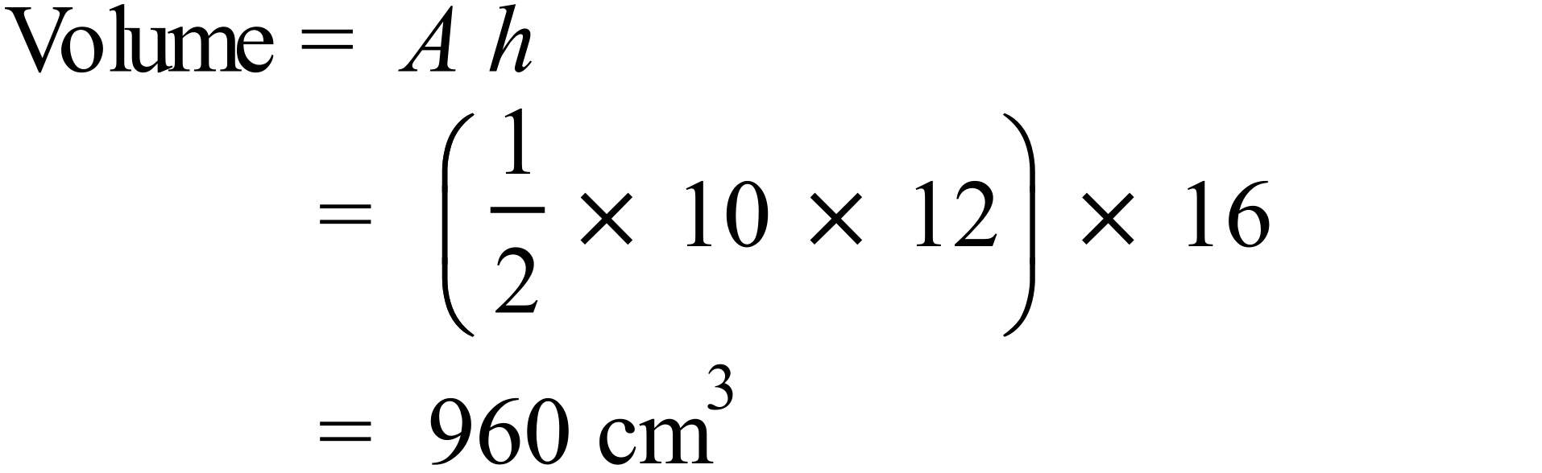 |  |  | 1 mark for correct answer
 | b) | 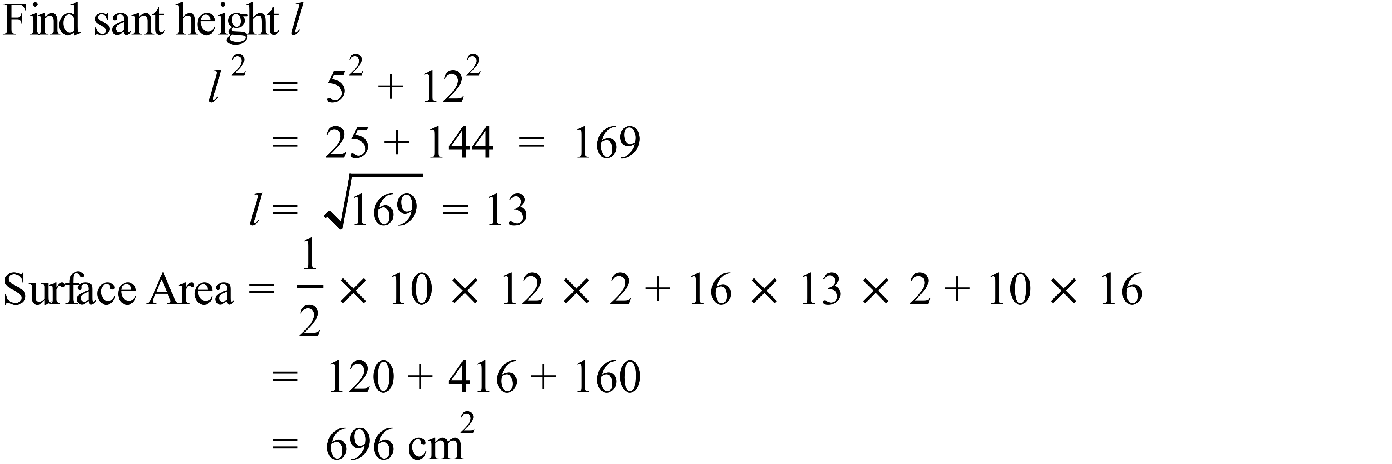 |  |  | 2 marks for correct answer  1 mark for an answer calculated using the wrong slant height or which has another similar simple error.
78. | a) | 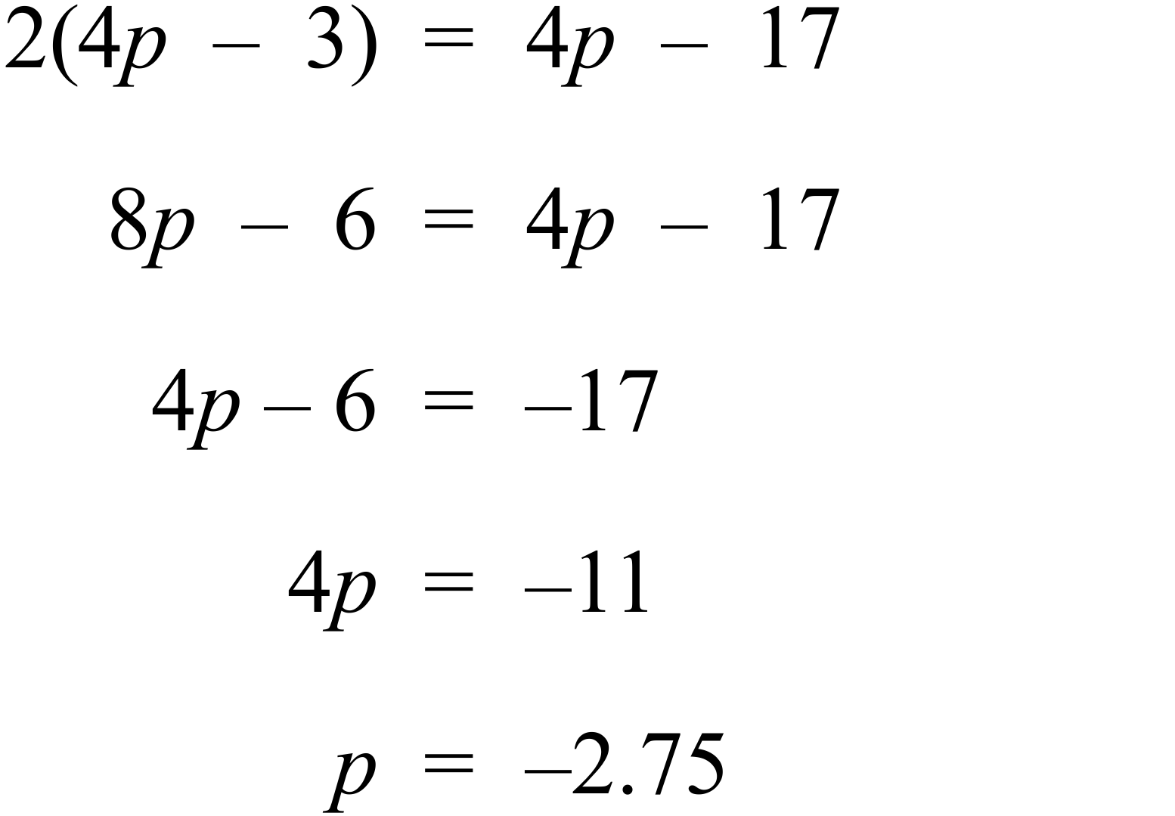 |  |  | 2 marks for correct answer found by any valid method including trial and error.  1 mark for an incorrect answer which has valid working toward answer with minor error in algebra or calculation
 | b) | 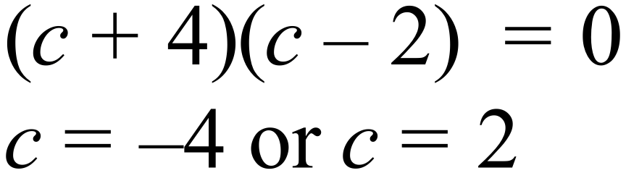 |  |  | 1 mark for correct answer
 | c) | 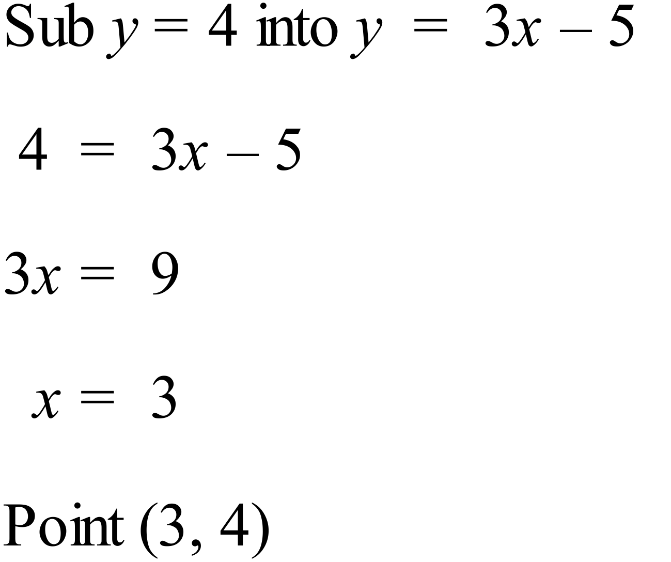 |  |  | 1 mark for correct answer
79. |  | 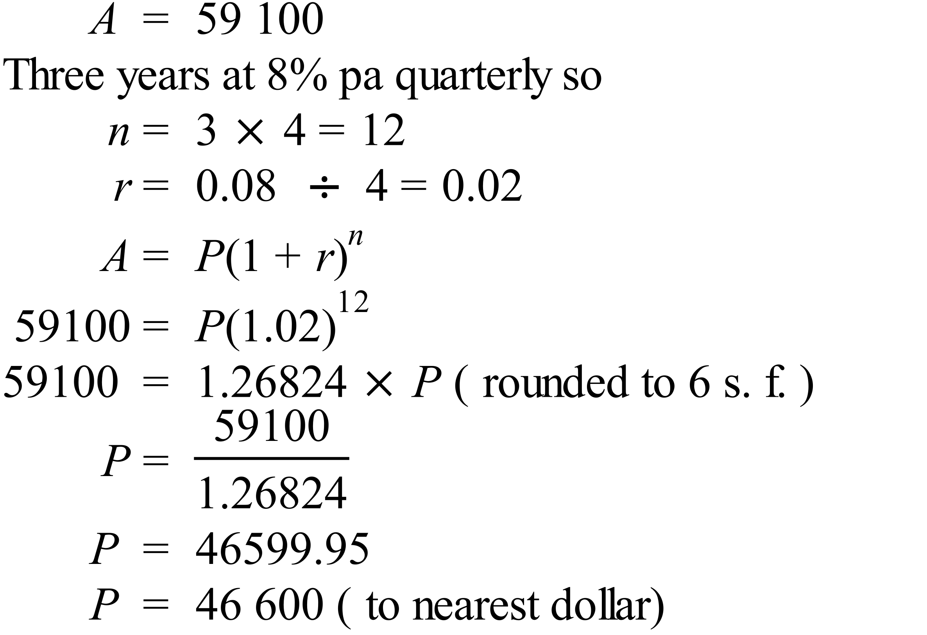 |  |  | 2 marks for correct answer found by any valid method including trial and error using the formula.  1 mark for an incorrect answer which uses the compound interest formula but has an error in substitution, calculation or in changing to the quarterly rates.
80. |  | 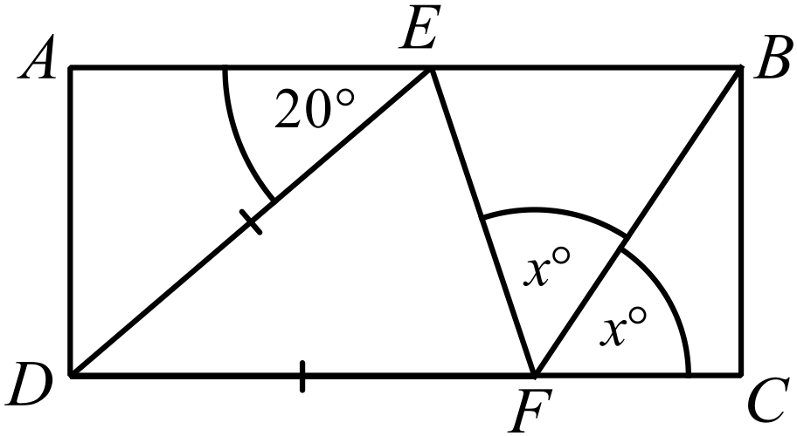  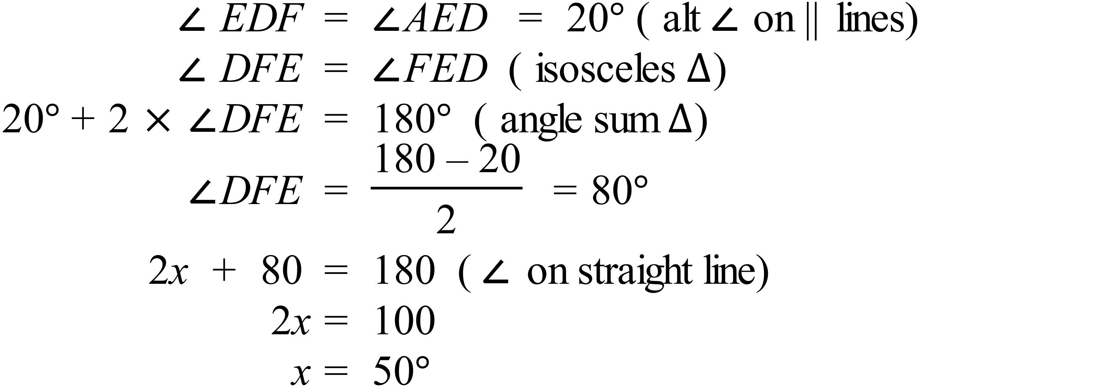 |  |  | 2 marks for correct answer with reasoning.  1 mark for an incorrect answer which has working which includes some correct and relevant reasoning
81. | a) | 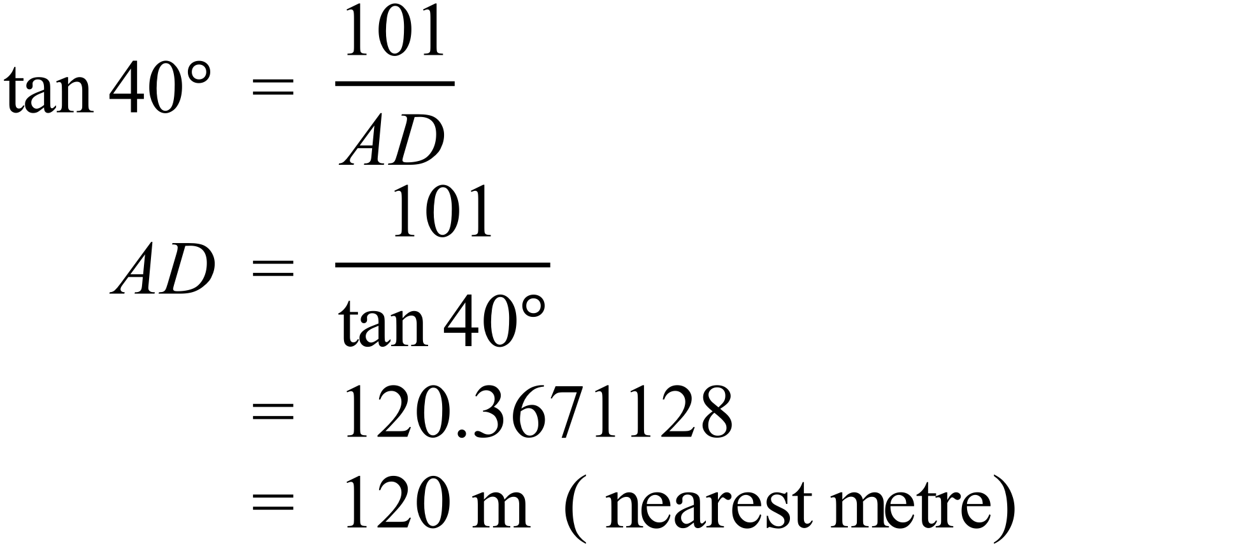 |  |  | 1 mark for correct answer
 | b) | 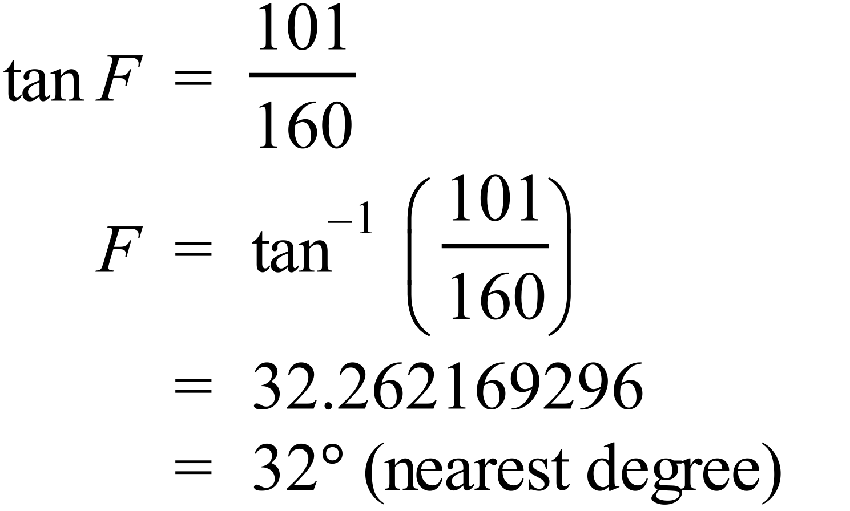 |  |  | 1 mark for correct answer
 | c) | 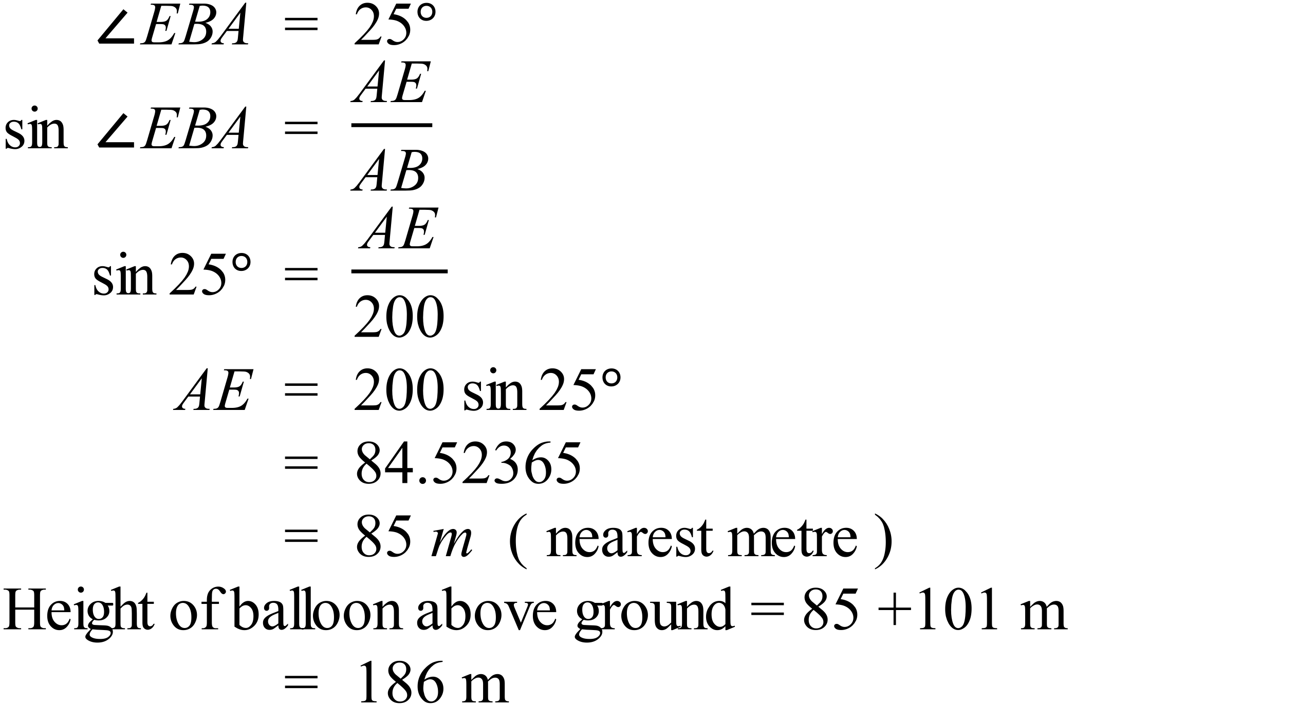 |  |  | 2 marks for correct answer  1 mark for an answer with a minor error or which only finds the distance AE.
82. | a) |  |  |  | 1 mark for correct answer
 | b) | 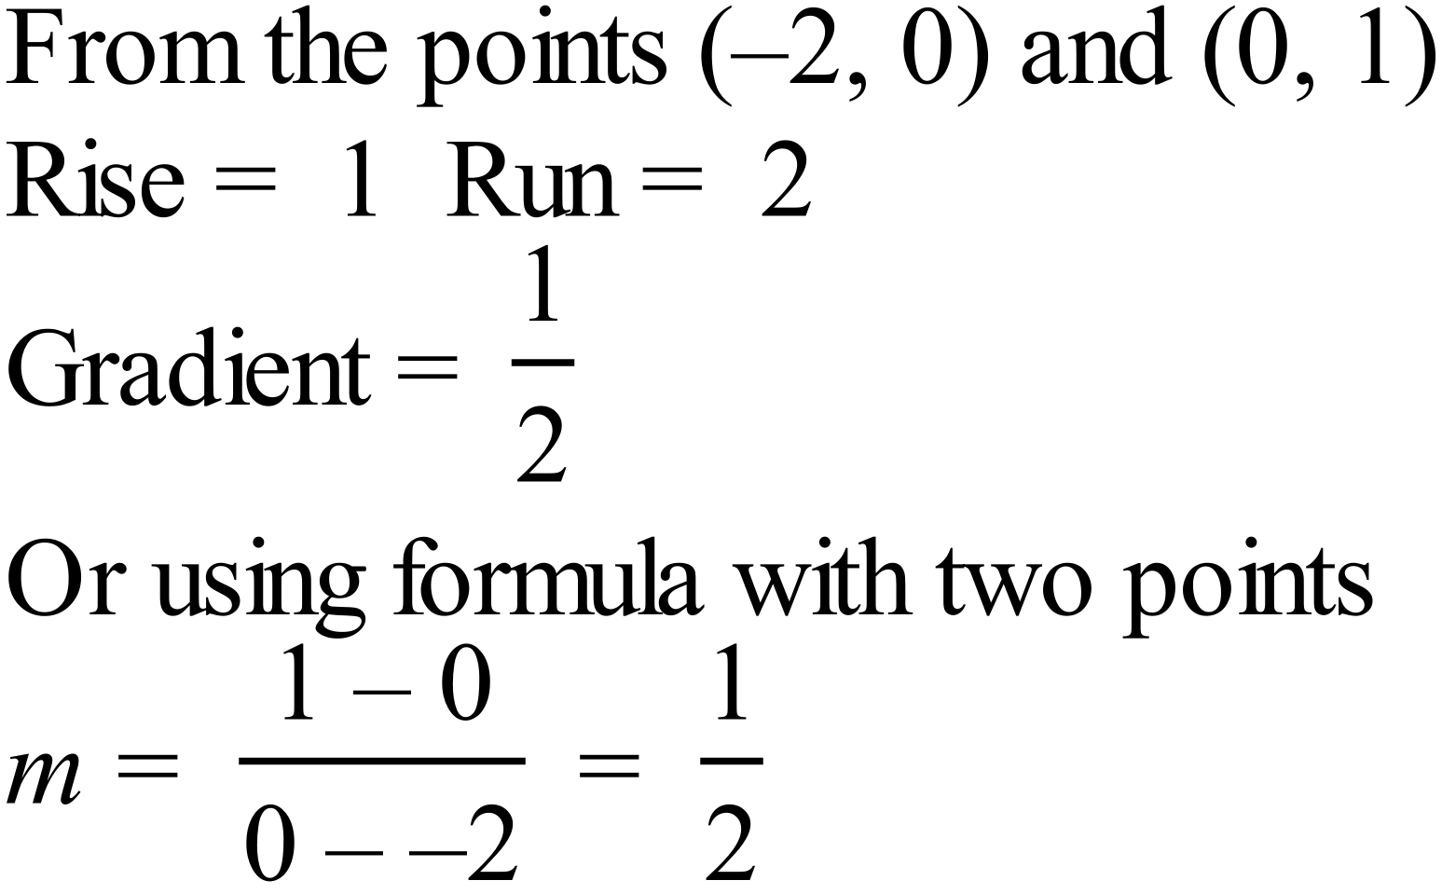 |  |  | 1 mark for correct answer
 | c) | 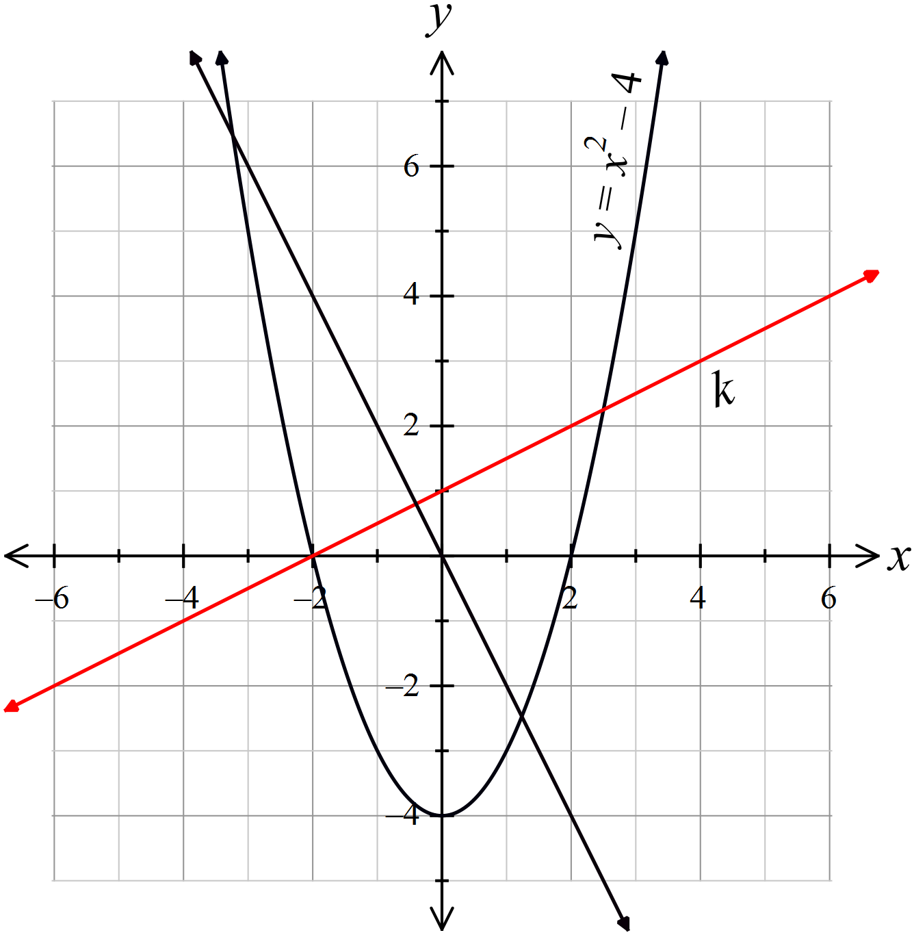  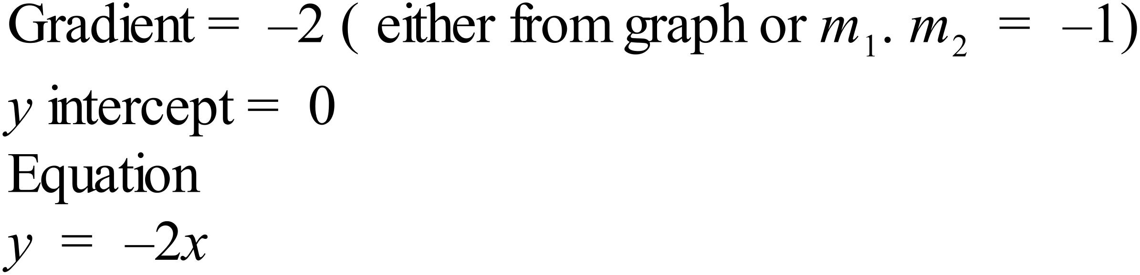 |  |  | 1 mark for correct line drawn on number plane  1 mark for correct equation
83. | a) | 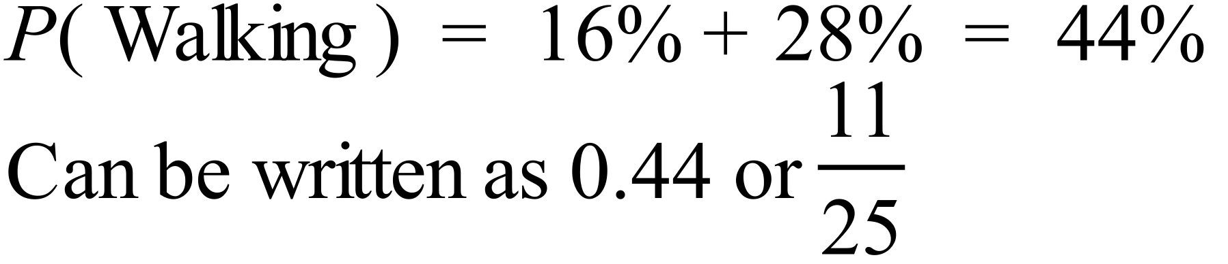 |  |  | 1 mark for correct answer
 | b) | 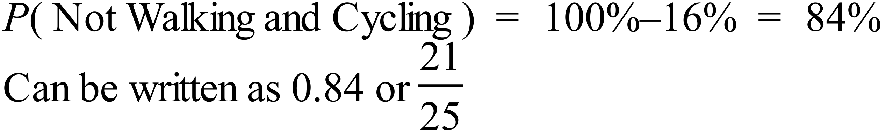 |  |  | 1 mark for correct answer

